

|  |  |  |
| --- | --- | --- |
| **Module Code** | **:** | CT026-3-1-SAAD – Systems Analysis and Design |
| **Intake Code** | **:** | APD1F2409CS(CYB) |
| **Lecturer Name** | **:** | Raheem Mafas |
| **Hand in Date** | **:** | 26th March 2025 |
| **Tutorial No.** | **:** | T-26 |
| **Group No.** | **:** | Group 11 |
| **Group Leader** | **:** | AHMED MIRAHUSAIN ALVI |

|  |  |
| --- | --- |
| **Student ID** | **Student Name** |
| TP084807 | AHMED MIRAHUSAIN ALVI |
| TP085531 | SAZID UR RAHMAN KHAN |
| TP085327 | SULTAN ABDULLA OMAR TAKRORI |
| TP085562 | MAHRUS SHAMSUL AHSAN |
| TP085042 | MOHAMMED YOUSEF MOHAMMED MOHAMMED |
| TP085097 | ABDALLAH MOHAMED MAHMOUD MOHAMED MAHMOUD |

**TABLE OF CONTENTS**

ACKNOWLEDGEMENT 1

CHAPTER 1: INTRODUCTION 2

**1.1** CodeNova 2

**1.2** Vision 3

**1.3** Mission 3

**1.4** Motto 3

**1.5** Assumptions Made 3

**1.6** Overview of The Present Operational Process 4

**1.7** Proposed Process Improvements 5

**1.8** Present Operational Process Diagram 6

CHAPTER 2: PROBLEM IDENTIFICATION & SOLUTION 7

**2.1** Fragmented & Disconnected Systems 7

**2.1.1** Proposed Solution 8

**2.2** Lack of Predictive Analytics for Demand Forecasting 9

**2.2.1** Proposed Solution 10

**2.3** Lack of Integration with Third-Party Services 12

**2.3.1** Proposed Solutions 13

**2.4** Inadequate Guest Data Utilization for Personalized Services 15

**2.4.1** Proposed Solution 16

**2.5** Poorly Managed Maintenance & Housekeeping Management 17

**2.5.1** Proposed Solutions 19

**2.6** Other Related Issues and Solutions 20

**2.7** Aims 21

**2.8** Objectives 22

CHAPTER 3: PROJECT PLANNING 23

**3.1** Software Development Life Cycle (SDLC) 23

**3.1.1** Phase 1: Planning 23

**3.1.2** Phase 2: System Analysis 25

**3.1.3** Phase 3: System Design 26

**3.1.4** Phase 4: System Implementation 27

**3.1.5** Phase 5: System Security & Support 28

**3.2** Gantt Chart 29

**3.3** Workload Matrix 30

CHAPTER 4: FEASIBILITY STUDY 31

**4.1** Operational Feasibility 31

**4.1.1** Performance 31

**4.1.2** Information 31

**4.1.3** Economy 32

**4.1.4** Control 32

**4.1.5** Efficiency 33

**4.1.6** Service 33

**4.2** Technical Feasibility 34

**4.3** Economic Feasibility 35

**4.4** Schedule Feasibility 38

CHAPTER 5: SYSTEM ANALYSIS 39

**5.1** Functional Requirements 39

**5.2** Non-Functional Requirements 41

**5.3** Architecture Requirements 43

**5.4** Business Requirements 46

**5.5** System / Technical Requirements 48

**5.6** User Requirements 51

**5.7** Security Requirements 54

**5.8** User Interface Requirements 56

**5.8.1** Administrator 56

**5.8.2** Shelter Staff 56

**5.8.3** Volunteers 57

**5.8.4** Adopter Interface 58

**5.8.3** Donor Interface 58

CHAPTER 6: DESIGN DIAGRAM 59

**6.1** System Context Diagram (SCD) 59

**6.2** Data Flow Diagram (DFD-Level 0) 60

**6.3** Entity Relationship Diagram (ERD) 61

CHAPTER 7: INTERFACE DESIGN 62

**7.1** Adopter Interface 62

**7.1.1** Input Interface 62

**7.1.2** Output Interface 65

**7.2** Administrator Interface 69

**7.3** Shelter Staff Interface 73

**7.4** Donor Interface 75

**7.4.1** Input Interface 75

**7.4.2** Output Interface 76

**7.5** Volunteer Interface 78

**7.5.1** Input Interface 78

**7.5.2** Output Interface 79

CHAPTER 8: REQUIREMENT GATHERING 81

**8.1**Ahmed Mirahusain Alvi - Document Review 81

**8.1.1** An Overview 81

**8.1.2** Advantages 81

**8.1.3** Limitations 82

**8.1.4** Conclusion 82

**8.2** Sultan Abdulla Omar Takrori – Research 83

**8.2.1** An Overview 83

**8.2.2** Advantages 83

**8.2.3** Limitations 84

**8.2.4** Conclusion 84

**8.3** Mohammed Yousef Mohammed Mohammed – Sampling 85

**8.3.1** An Overview 85

**8.3.2** Advantages 85

**8.3.3** Limitations 86

**8.3.4** Conclusion 86

**8.4** Abdallah Mohamed Mahmoud Mohamed Mahmoud – Observation 87

**8.4.1** An Overview 87

**8.4.2** Advantages 87

**8.4.3** Limitations 87

**8.4.4** Conclusion 88

**8.5** Sazid Ur Rahman Khan – Interview 88

**8.5.1** An Overview 88

**8.5.2** Advantages 89

**8.5.3** Limitations 89

**8.5.4** Conclusion 90

**8.6** Mahrus Shamsul Ahsan – Questionnaire 90

**8.6.1** An Overview 90

**8.6.2** Advantages 91

**8.6.3** Limitations 91

CHAPTER 9: DESIGN 95

**9.1** Ahmed Mirahusain Alvi 95

**9.2** Sultan Abdulla Omar Takrori 96

**9.3** Mohammed Yousef Mohammed Mohammed 97

**9.4** Abdallah Mohamed Mahmoud Mohamed Mahmoud 98

**9.5** Sazid Ur Rahman Khan 99

**9.6** Mahrus Shamsul Ahsan 100

REFERENCES 101

# ACKNOWLEDGEMENT

We would like to express our deepest gratitude to **Mr. Mafas Raheem** for his valuable guidance, support, and encouragement throughout the preparation and completion of our **Systems Analysis and Design (SAAD)** assignment. His insights, clear explanations, and constructive feedback greatly helped us in understanding the core concepts and applying them effectively in our work. This assignment not only enhanced our technical knowledge but also improved our analytical and problem-solving skills. We are sincerely grateful for the opportunity to learn under his supervision and for the continuous support he has shown us. We also express our deep gratitude to our colleagues and peers, whose collaboration and exchange of ideas have greatly enriched our understanding of the subject. A heartfelt thank you to our friends: Sultan Abdulla Omar Takrori, Mohammed Yousef Mohammed Mohammed, Mahrus Shamsul Ahsan, Ahmed Mirahusain Alvi, Sazid Ur Rahman Khan, Abdallah Mohamed Mahmoud Mohamed Mahmoud, for their continuous support, motivation, and cooperation throughout this journey.

# CHAPTER 1: INTRODUCTION

## **1.1** CodeNova



CodeNova is a leading software development company, based in Kuala Lumpur, Malaysia. Founded with a passion for innovation and excellence, it is committed to changing the way businesses operate through the power of technology. We specialize in designing and building custom digital solutions for our clients in multiple sectors, including healthcare, education, retail, logistics, and non-profit organizations. At CodeNova we believe innovation is the key to sustainable success. Our approach combines creativity, technical expertise, and a deep understanding of user needs, to deliver practical, easy-to-use, and scalable software systems. From enterprise systems and mobile applications to intelligent data platforms and cloud solutions, we ensure every project is aligned with our client’s vision and business goals. CodeNova is proud to be a trusted technology partner for organizations that want to boost their efficiency, improve user engagement, and achieve significant digital growth. Whether to streamline internal processes or improve customer experiences, we strive to make a tangible difference through smart software solutions.

## **1.2** Vision

To be a leading force in digital transformation through innovative, reliable, and smart software solutions that help empower businesses and improve lives across the board.

## **1.3** Mission

Our mission is to harness the power of technology to develop intelligent, user-focused software solutions that address real-world challenges. We are committed to delivering high-quality, scalable systems through collaboration, creativity, and continuous improvement.

## **1.4** Motto

*“Innovate. Integrate. Elevate.”*

## **1.5** Assumptions Made

1. All end users (shelter-staff and potential adopters) have access to the Internet and basic digital literacy skills.
2. The shelter uses a completely manual system that includes paper records, phone calls and physical forms to receive, track and adopt pets.
3. The budget available for the project is RM80,000 and the development timeline is 6 months, as allocated by the shelter management.
4. Pet admission includes both strays and surrendered animals, each with different medical needs and adoption requirements.
5. The shelter currently does not have a system to automate post-adoption follow-ups or maintain central health records.
6. Volunteers and partner vets collaborate with the shelter but use separate communication tools like WhatsApp or phone calls.

## **1.6** Overview of The Present Operational Process

Currently, Pet4U primarily relies on manual processes to manage pet adoptions. These processes involve multiple steps, all managed offline, resulting in decreased efficiency and delayed operations. Below is an overview of the main areas of the current operational workflow:

1. Pet Registration:

Each pet is registered manually in an official register. Shelter-staff enter details such as breed, age, and medical history. This process is time-consuming and exposes pets to errors, making it difficult to track pet health records effectively.

2. Adoption Requests and Applicant Screening:

Adoption applications are processed manually via forms or by phone. Potential adopters submit applications, which are reviewed by staff. However, there is no automated system to check applicants' suitability or track their progress. This process can take a long time, resulting in a delay in pet matching.

3. Adoption Tracking and Communication:

Adoption requests are communicated with adoption status updates via phone calls and e-mail, without immediate tracking of potential pet owners. Shelter staff manually notify applicants of available pets and updates, resulting in inefficiency and missed opportunities.

4. Post-Adoption Follow-up:

Post-adoption follow-up is done informally via phone calls or email, without an organized system in place to ensure pets are properly cared for. There is no central platform to follow up on the animals' status after adoption.

## **1.7** Proposed Process Improvements

To address the inefficiencies in Pet4U’s current manual operations, the following digital process improvements are proposed as part of the new Pet Adoption Management System (PAMS):

1. Automation of Core Operations:

The PAMS system will automate basic processes, such as pet registration, adoption applications, medical records management, and appointment scheduling. This will reduce paperwork, eliminate human error, and significantly speed up your adoption process.

2. Centralized Database System:

A central, secure electronic database will store all pets and adopters' information. Authorized employees can access and update data in real time, ensuring transparency and consistency of data across departments. This allows for better coordination and monitoring of all shelter activities.

3. Integrated Communication and Follow-Up Tools:

Built-in tools, such as email or text notifications, appointment reminders, and post-adoption surveys will improve communication with adopters. This ensures better interaction, responsible pet ownership, and the collection of opinions.

4. Third-Party Integration:

The system will support integration with veterinary services, microchip databases and social media platforms to expand communication, enhance pet health monitoring and enhance public participation in adoption campaigns.

## **1.8** Present Operational Process Diagram

Figure 1 shows flowchart of present operational process

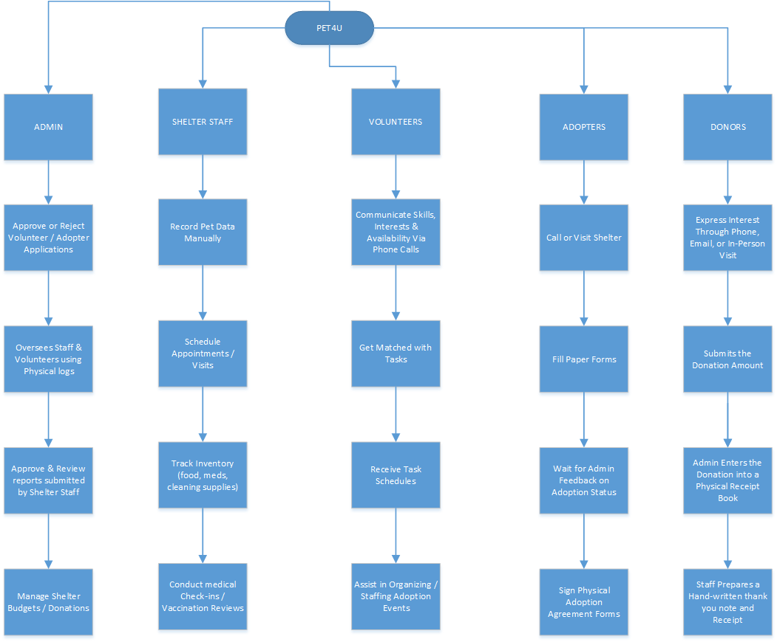

# CHAPTER 2: PROBLEM IDENTIFICATION & SOLUTION

## **2.1** Fragmented & Disconnected Systems

|  |  |
| --- | --- |
| **Issue** | **Fragmented and Disconnected Systems** |
| **Description** | Different operational areas (e.g., animal intake, medical records, donor tracking) at Pet4U are handled manually or with separate, non-integrated tools like paper files and basic spreadsheets. As a result, data is isolated, updates are delayed, and overall operations are inefficient. |
| **Cause** | * Pet4U relies on multiple manual processes and disconnected records, which were not designed to interact or sync with each other. * There is no centralized digital platform to consolidate pet, adopter, volunteer, and donor information into a unified system. |
| **Effect** | * Staff are delayed in accessing real-time information like room status or guest preferences, so operations are inefficient. * This also means inconsistent guest experience; the front desk may not know when rooms are ready for check-in or housekeeping may not know guest-specific requests. |

### **2.1.1** Proposed Solution

|  |  |
| --- | --- |
| **Solution** | **Implementing an Integrated Pet Adoption Management System (PAMS)** |
| **Description** | |  | | --- | |  |   An Integrated Pet Adoption Management System (PAMS) will centralize all shelter operations onto a single, cloud-based platform. It will connect animal intake, medical records, adoption processes, volunteer management, and donor tracking. Real-time updates will ensure accurate information flow, reduce manual duplication, and improve overall shelter efficiency and adoption success rates. Staff will have immediate access to vital information, supporting faster adoptions and better animal care. |
| **Implementation Steps** | * Conduct a full audit of current shelter workflows and data storage practices to identify gaps and inefficiencies. * Select or develop a scalable cloud-based shelter management system that includes modules for animal intake, medical history, adoptions, volunteers, and donor management. * Migrate existing paper records and spreadsheets into the new platform, ensuring data accuracy. * Implement role-based access control (RBAC) to protect sensitive information and limit access based on user responsibilities. * Train shelter staff, volunteers, and administrators on how to use the system effectively. * Continuously monitor system usage and gather feedback to improve features and processes over time. |
| **Benefits** | * Breaks down information silos by centralizing all pet and operational data. * Reduces human errors caused by manual data handling. * Speeds up the adoption process with real-time pet availability and applicant screening. * Enhances animal care by automating medical follow-up reminders and tracking. * Strengthens donor and volunteer engagement through organized contact management and communication. * Reduces administrative overhead, freeing up staff time for direct animal care. |

## **2.2** Lack of Predictive Analytics for Demand Forecasting

|  |  |
| --- | --- |
| **Issue** | **Lack of Predictive Analytics for Demand Forecasting** |
| **Description** | At Pet4U, daily operations such as animal intake, adoptions, medical treatments, and volunteer coordination are handled manually without the use of predictive analytics or data-driven insights. Shelter decisions are made reactively rather than proactively, which limits the shelter’s ability to plan effectively. Without tools to forecast adoption trends, incoming animal volume, or upcoming medical needs, Pet4U struggles to manage resources efficiently, resulting in overcrowding, stretched staff, delayed adoptions, and inconsistent animal care. The shelter also misses opportunities to launch targeted campaigns or plan events during peak interest periods, limiting adoption rates and donor engagement. |
| **Cause** | * Manual recordkeeping makes it difficult to analyse trends in animal intake, adoption success, or medical treatments over time. * No central system aggregates data to generate forecasts or identify patterns, such as seasonal fluctuations in pet surrenders or adoptions. * Lack of automated alerts or dashboards prevents management from spotting emerging problems like overcrowding or medical resource shortages in advance. * Absence of predictive models for volunteer scheduling and donor engagement activities, leading to inefficient human resource allocation and fundraising efforts. |
| **Effect** | * Shelter space becomes overcrowded during high intake periods, putting stress on animals and staff, and increasing risk of disease spread. * Food, vaccines, and medical supplies run short unexpectedly, disrupting animal care schedules and increasing costs. * Staff cannot proactively adjust marketing or outreach strategies to boost adoptions during slow periods or capitalize on public interest during peak seasons. * Animals remain in the shelter longer, leading to higher operational costs and reduced animal well-being. * Volunteers and donors are not engaged optimally due to poor planning, resulting in missed opportunities for additional support during critical times. * Management lacks real-time performance indicators, making it difficult to create effective long-term strategies for shelter growth and sustainability. |

### **2.2.1** Proposed Solution

|  |  |
| --- | --- |
| **Solution** | **Implementing a Predictive Analytics and Reporting Module** |
| **Description** | CodeNova will implement a Predictive Analytics and Reporting Module integrated into the new centralized management system. This module will collect real-time operational data from animal intakes, adoptions, medical treatments, volunteer shifts, and donor activities to generate actionable forecasts. Using built-in analytics tools and machine learning algorithms, Pet4U can predict periods of high intake, anticipate supply shortages, identify animals at higher risk of long shelter stays, and better plan adoption campaigns and fundraising events. This enables proactive decision-making, better resource allocation, improved animal welfare, and higher adoption success rates. |
| **Implementation Steps** | * Integrate a predictive analytics tool within the Pet Adoption Management System (PAMS) to gather and process real-time operational data. * Define key data points to track (e.g., number of intakes per month, adoption rates, supply consumption rates, medical treatment schedules, volunteer hours). * Develop forecasting models to predict shelter occupancy trends, medical resource needs, and adoption surges. * Set up automated dashboards and reports that alert staff to upcoming challenges, such as anticipated overcrowding or resource shortages. * Train management and key staff members to interpret and act upon predictive reports and trend analyses. |
| **Benefits** | * Enables proactive management of shelter capacity, reducing the risks of overcrowding and animal stress. * Helps anticipate and prevent shortages of critical resources like food, vaccines, and medical supplies. * Supports more effective adoption marketing by identifying the best times to run campaigns or host adoption drives. * Improves animal care through timely medical treatment scheduling and follow-ups. * Enhances volunteer and donor engagement by predicting optimal periods for outreach and events. * Provides management with real-time insights into shelter operations, |

## **2.3** Lack of Integration with Third-Party Services

|  |  |
| --- | --- |
| **Issue** | **Lack of Integration with Third-Party Services** |
| **Description** | |  | | --- | |  |   At Pet4U, the limited integration with third-party services—such as veterinary clinics, microchipping providers, animal welfare agencies, and adoption platforms—creates workflow disruptions and limits outreach. Currently, shelter staff must manually coordinate external services like veterinary appointments, microchip registration, and pet promotion on adoption websites or social media platforms. This not only consumes valuable time but also leads to inconsistencies and lost opportunities to streamline operations, improve animal care, and increase adoption visibility. |
| **Cause** | * Manual Coordination with External Partners: Veterinary care, microchipping, and pet promotions are handled manually, with no digital linkage to Pet4U’s internal records. * No API Integration: The current shelter system lacks APIs that would allow real-time synchronization with external platforms (e.g., PetFinder.my, veterinary databases, and animal welfare organizations). * Disconnected Workflows: Each third-party process requires separate communication, paperwork, or logins, making it difficult to maintain consistency and data accuracy. * Outdated Tech Stack: The shelter's current tools are not built to support integrations or automate tasks involving external systems. |
| **Effect** | * Delayed Services: Scheduling veterinary visits, registering microchips, or updating pet profiles on external platforms takes longer, delaying adoptions and medical follow-ups. * Inconsistent Data: Information may not be updated uniformly across all platforms, leading to confusion about pet availability or health status. * Increased Admin Workload: Staff spend excessive time on coordination that could be automated, pulling them away from core shelter duties. * Reduced Outreach and Missed Adoptions: Lack of integration with adoption platforms and social media limits the visibility of pets to potential adopters, reducing adoption rates. * Missed Collaboration Opportunities: Pet4U may lose out on partnerships or joint campaigns with vets, NGOs, or government agencies due to poor system interoperability. |

### **2.3.1** Proposed Solutions

|  |  |
| --- | --- |
| **Solution** | **Integration with Key Third-Party Services via APIs and Automated Sync Tools** |
| **Description** | CodeNova will implement API-based integrations and synchronization tools within its new Pet Adoption Management System (PAMS) to connect with essential third-party services. This includes veterinary clinics for automated appointment scheduling and medical updates, national pet microchip registries for instant registration and tracking, and external adoption platforms like PetFinder.my and social media for real-time pet profile updates. These integrations will streamline workflows, reduce errors, save staff time, and boost adoption visibility and animal care quality. The system will also enable automated two-way data exchange, so changes made in the shelter’s database are reflected immediately across partner platforms and vice versa. |
| **Implementation Steps** | * Identify high-priority third-party partners (e.g., local vets, microchip databases, adoption sites, welfare organizations). * Develop or implement existing APIs to enable seamless communication between PAMS and external systems. * Integrate scheduling tools with veterinary partners to automate bookings and treatment updates. * Connect PAMS with adoption websites and social media platforms to auto-update pet listings and availability status. * Ensure secure data exchange through encryption and implement permission-based access for third parties. * Set up monitoring systems to detect integration failures and notify staff in real time. * Train shelter staff on managing and troubleshooting integrated systems. |
| **Benefits** | * Improved Efficiency: Reduces manual coordination and paperwork with external providers, freeing staff for core shelter tasks. * Real-Time Updates: Automatically syncs pet availability, adoption status, and medical records across systems, ensuring consistency. * Better Animal Care: Streamlines veterinary follow-ups and microchip registration, leading to better health tracking and post-adoption safety. * Increased Adoption Reach: Expands exposure of adoptable pets by instantly updating profiles across multiple platforms. * Data Accuracy: Minimizes human error and eliminates data duplication by unifying system inputs. * Strengthened Partnerships: Enhances collaboration with external stakeholders by offering a professional, tech-enabled interface. |

## **2.4** Inadequate Guest Data Utilization for Personalized Services

|  |  |
| --- | --- |
| **Issue** | **Inadequate Guest Data Utilization for Personalized Services** |
| **Description** | Although Pet4U collects valuable information from adoption applicants—such as lifestyle, preferences, household type, and past pet ownership—this data is not effectively used to personalize the pet adoption journey. Every adopter receives similar pet suggestions and follow-up interactions, regardless of their unique background or needs. This one-size-fits-all approach reduces the likelihood of successful matches and long-term pet retention. Moreover, there is no structured use of adopter behavior or interaction history to tailor communications, follow-ups, or post-adoption support, leading to weaker adopter engagement and missed chances to build lasting relationships. |
| **Cause** | * Data collected during adoption applications is not stored or analyzed in a centralized system. * Lack of intelligent matching tools to recommend pets based on adopter profiles and previous interactions. * No analytics engine in place to identify patterns in adopter preferences or predict which pets are more likely to succeed in specific homes. * Staff are unable to access or act on previous adopter feedback to refine the adoption experience. * There is no automated personalization in communication, such as tailored emails, follow-ups, or pet care tips. |
| **Effect** | * Poor adopter-pet matching, resulting in higher chances of pet returns or post-adoption issues. * Adopters feel disengaged or unsupported, reducing trust in the shelter and potential for word-of-mouth promotion. * Inability to target specific adopter types for special campaigns, leading to lower adoption rates for harder-to-place animals. * Lost opportunities to upsell services such as training programs, vet partnerships, or donation appeals. * Weaker adopter relationships, reducing repeat engagement, volunteer conversions, and long-term community support. |

### **2.4.1** Proposed Solution

|  |  |
| --- | --- |
| **Solution** | **Implementing an AI-Driven Adopter Personalization and Matching System** |
| **Description** | |  | | --- | |  |   To address the lack of personalized adopter engagement, CodeNova will introduce an AI-driven recommendation engine within its Pet Adoption Management System (PAMS). This system will use machine learning algorithms to analyse adopter data—such as lifestyle, preferences, pet experience, home environment, and interaction history—to suggest the most suitable pets. It will also tailor communication and follow-up strategies based on adopter behaviour. Personalized pet recommendations, reminders, care tips, and engagement content will help create a more meaningful adoption experience and improve long-term pet placement success. |
| **Implementation Steps** | * Collect structured adopter data through digital application forms that include lifestyle, pet history, housing situation, and preferences. * Train AI algorithms using past adoption records to recognize successful match patterns and develop automated pet recommendations. * Integrate the recommendation engine with the public-facing pet listing portal to suggest matches in real time. * Use behavioral data (such as search history and clicked profiles) to refine future suggestions. * Implement automated, personalized communication—like follow-up emails, care instructions, or reminders—based on adopter profile and stage in the adoption journey * Continuously improve algorithms using feedback loops from adoption outcomes and satisfaction surveys. |
| **Benefits** | * Improved Pet-Adopter Matching: Increases the likelihood of successful adoptions by aligning pet personalities and care needs with adopter lifestyles. Reduced Administrative Load: Staff can then concentrate more on looking after guests rather than manually managing bookings with third parties. * Reduced Pet Returns: Personalized matches reduce mismatched placements, leading to more stable, long-term adoptions. * Enhanced Adopter Experience: Tailored suggestions and messages make adopters feel understood and supported. * Data-Driven Engagement: Allows targeted outreach and follow-ups, improving communication and adopter loyalty. * Support for Underserved Animals: AI can identify which adopters might be open to adopting senior, special-needs, or long-stay animals. * Higher Conversion Rates: Smart suggestions and timing-based follow-ups increase the likelihood of adoption completion. |

## **2.5** Poorly Managed Maintenance & Housekeeping Management

|  |  |
| --- | --- |
| **Issue** | **Poorly Optimized Facility Maintenance and Animal Care Scheduling** |
| **Description** | At Pet4U, routine tasks such as cleaning kennels, feeding, and facility maintenance are done on fixed schedules rather than based on real-time needs. This results in wasted resources, inconsistent hygiene, and delayed responses to urgent issues. Critical maintenance is often reactive—only addressed after equipment failure or safety concerns arise. Additionally, care task scheduling (feeding, cleaning, administering medication) is not aligned with animal-specific conditions or shelter occupancy, which can affect both animal welfare and operational efficiency. |
| **Cause** | * Outdated task scheduling methods that do not account for real-time animal needs or environmental conditions. * No use of sensors or monitoring tools to assess kennel occupancy, temperature, humidity, or cleanliness levels. * Maintenance and cleaning issues are reported manually, delaying response times. * Tasks are assigned without centralized coordination, leading to duplicated efforts, or overlooked responsibilities. * No predictive maintenance model to anticipate equipment failure or wear-and-tear in high-use areas. |
| **Effect** | * Animals may be exposed to unsanitary or unsafe conditions, increasing health risks and stress levels. * Staff time is wasted on unnecessary or poorly timed cleaning and maintenance. * Emergency repairs lead to higher costs and operational disruption. * Resource overuse (cleaning supplies, water, electricity) due to inefficient scheduling increases expenses. * Lack of coordination causes task delays, missed treatments, or uneven workloads among staff. |

### **2.5.1** Proposed Solutions

|  |  |
| --- | --- |
| **Solution** | **Implementing a Smart Task Scheduling and Predictive Maintenance System** |
| **Description** | To improve operational efficiency and animal welfare, CodeNova will implement a smart scheduling and predictive maintenance system integrated within the shelter's digital platform. This system will automate care task assignments (cleaning, feeding, medical rounds) based on real-time shelter conditions, animal needs, and occupancy. Additionally, predictive maintenance tools will monitor equipment usage and flag issues before breakdowns occur. Smart sensors and task-tracking dashboards will allow staff to prioritize work, reduce waste, and ensure that animal care is timely, consistent, and proactive. |
| **Implementation Steps** | * Install environmental sensors (e.g., temperature, humidity, ammonia levels) in key animal areas to monitor real-time conditions that may trigger urgent cleaning or ventilation needs. * Use animal-specific profiles and intake data to generate individualized care schedules (feeding, medication, hygiene). * Integrate predictive maintenance software to monitor shelter equipment usage patterns and schedule pre-emptive servicing. * Deploy a task management dashboard to assign, track, and verify care and maintenance tasks in real time across staff shifts. * Allow staff to log urgent issues through mobile devices, triggering alerts and task reprioritization. * Review sensor data and maintenance logs monthly to optimize task intervals and identify problem areas. |
| **Benefits** | * Improved Animal Welfare: Ensures that cleaning, feeding, and medical care are provided based on actual animal and environmental needs, not fixed routines. * Reduced Operational Costs: Minimizes waste of cleaning materials, food, water, and electricity by aligning resources to demand. * Fewer Equipment Breakdowns: Predictive maintenance prevents failures and extends the life of critical shelter infrastructure. * Better Staff Productivity: Clear task assignments and real-time dashboards reduce confusion, redundancy, and missed responsibilities. * Faster Response to Issues: Real-time alerts and logging enable quick action on urgent facility or care problems. * Data-Driven Planning: Helps management analyse task performance and resource use to continuously improve workflows and staff scheduling. |

## **2.6** Other Related Issues and Solutions

In addition to the main operational challenges already discussed, Pet4U also faces several other critical issues that affect efficiency, staff coordination, data accuracy, and sustainability. These issues are explored further in the System Analysis and Design chapter 5 of this report. A summary is provided below:

* Manual Volunteer Scheduling
* Problem: Double Volunteer schedules are managed manually, leading to inconsistent shift coverage, overlapping duties, or under-utilized help on high-demand days.
* Solution: Implement a digital volunteer scheduling system with calendar syncing, role-based task assignments, and notifications to improve coordination and accountability.
* No Centralized Medical Supply Inventory
* Problem: Lack of real-time tracking leads to expired medicines, understocking of essential supplies, or over-purchasing.
* Solution: Introduce a centralized inventory management module with automated stock alerts and expiry tracking to optimize resource use and reduce waste.
* Inadequate Pet Intake Screening Process
* Problem: Inconsistent or incomplete data collection during intake can lead to missed medical issues, inappropriate housing, or poor adoption outcomes.
* Solution: Standardize digital intake forms with required health checks, behaviour notes, and tagging systems to ensure every animal is properly assessed and documented.
* No Asset Tracking for Equipment and Resources
* Problem: Common-use equipment like crates, cleaning tools, and microchip scanners are often misplaced, unaccounted for, or left unused.
* Solution: Deploy an asset tracking system using QR codes or RFID tags to monitor location, usage, and maintenance status of shelter equipment.
* Poor Waste Management Practices
* Problem: Inefficient handling of animal waste and general shelter trash can increase health risks, violate municipal guidelines, and damage community perception.
* Solution: Implement a digital waste tracking and management system to monitor disposal frequency, identify areas of excessive waste, and support eco-friendly practices like composting and recycling.

## **2.7** Aims

This project aims to develop an Integrated Pet Adoption Management System (PAMS) for Pet4U, a non-profit animal shelter in Kuala Lumpur. The system will reduce reliance on manual processes, improve operational efficiency, and enhance the pet adoption experience for both shelter staff and prospective adopters. It will serve as a centralized digital platform for managing pets, adoptions, volunteers, donors, and third-party services.

Beyond internal improvements, the system also supports Pet4U’s long-term sustainability goals by reducing paper use, optimizing resource allocation (e.g., food, medicine, cleaning supplies), and enabling data-driven decision-making. Ultimately, it will help increase adoption rates, improve animal welfare, and build stronger connections between the shelter and the public.

## **2.8** Objectives

To achieve this aim, the PAMS system will address core challenges currently faced by Pet4U, including:

1. To provide an online adoption and intake system that involves a centralized digital adoption system with the possibility of adopters browsing their available pets, filtering their preferences, and submitting their applications online.
2. To implement real-time medical record system and automated vaccination, treatment reminder.
3. To improvematchmaking and lower returns with AI-enabled pet-adopter compatibility.
4. To introduce an intelligent task scheduling program to distribute distribution of feeding, cleaning, and care of medical needs according to real needs and conditions.
5. To enable the incorporation of veterinary clinics, microchip registries and adoption platform to facilitate external services.
6. To create a digital module of volunteer management, donor management including schedules tools, monitoring of activities, and automated notifications of engagement.
7. To provide a predictive analytics dashboard to forecast shelter occupancy, track adoption trends, and support planning.
8. To support a QR tagging, or RFID based asset tracking system of shelter equipment and medical supplies.
9. To include a computerized waste management application to assist in achieving hygiene and sustainability objectives.
10. To enforce role-based access control and safe storage of data to ensure privacy of essential animal and adopter records.
11. To offer Personalized communication tools: These are mailers that are sent to various stakeholders as a personalized follow-up, care tips, and requests to donate.

# CHAPTER 3: PROJECT PLANNING

## **3.1** Software Development Life Cycle (SDLC)

The Software Development Life Cycle (SDLC) outlines a standardized framework for planning, creating, Implementing, and maintaining software systems. It ensures that the product meets technical expectations, user needs, and business goals (Clark, 2025). For Pet4U.org, the Pet Adoption Management System (PAMS) will be developed using this framework to streamline shelter operations and enhance the pet adoption experience through automation and AI-powered features. The following sections describe how each SDLC phase applies to this project:

### **3.1.1** Phase 1: Planning

This phase defines the foundation of the PAMS project, focusing on its scope, goals, budget, risks, and resource planning. Key goals include unifying pet listings, volunteer coordination, equipment tracking, and inventory management into one cloud-based platform.

The system will support features such as automatic pet listings, adoption appointment scheduling, equipment inventory tracking, and AI-powered pet matching. Exclusions—like financial accounting or veterinary integrations—are noted to prevent scope creep.

**Project Scopes**:

1. Centralized Pet Intake and Adoption Platform  
   One central online platform will allow shelter workers to enroll pets, keep track of medical history, and even accept adoption requests.
2. AI-Based Pet-Adopter Matching  
   The recommendation engine will ensure that wrong pets are not presented to the people adopting the pets by recommending pets depending on adopters, preferences, and lifestyle, and adoption history.
3. Smart Scheduling System  
   The scheduling of feeding, cleaning, and medical care will also be programmed in real time according to the needs of animals and staff or volunteers.
4. Third-Party Service Integration  
   Liaison with external services like veterinary practice, microchip registries, and adoption sites will help to coordinate better using the platform.
5. Real-Time Reporting and Analytics  
   On-screen dashboards will be used to monitor the important metrics like rates of adoption, settlement occupancy, the status of tasks and inventory status.
6. Secure, Role-Based Access  
   The access of each user role will be limited based on the role and this will be in line with the GDPR and HIPAA with regard to privacy and protection of data.

**Project Constraints:**

1. Budget Constraint  
   This project has to be done at a given budget of RM 70,000. Everything, including features, tools, licenses and hosting services should be planned within this budget.
2. Time Constraint  
   The project time is only up to 6 months. The learning curve as applied in all the levels of design/development, testing and deployment activities should be in line as this will result in the successful completion of the project within stipulated period.
3. Technology Stack Limitation  
   The system must be entirely constructed on an AWS platform. The tools and services that help use AWS are permitted only, producing a lack of flexibility in selecting third-party solutions (e.g., Lambda, DynamoDB, Cognito).
4. User Skill Level  
   End users (shelter staff and volunteers) may have limited technical skills. The system must therefore prioritize ease of use and require minimal training for daily operations.

**Deliverables:**

* Preliminary Investigation Report
* Project Scope Document
* Budget Estimate
* Risk Register
* Resource Allocation Plan
* Stakeholder Engagement Strategy

### **3.1.2** Phase 2: System Analysis

The analysis phase involves identifying current pain points and collecting detailed user requirements from shelter staff, volunteers, and adopters.

**System Requirements Gathering:**

1. Interviews with staff revealed inefficiencies in volunteer scheduling and inventory updates.
2. Observation of adoption workflows uncovered duplicated data entry and communication gaps.
3. Surveys & Questionnaires collected feedback from adopters who requested features like personalized pet suggestions and simplified appointment booking.
4. Document Review was taken to analyze previously developed forms of shelter, reports, and policy documents in order to learn about current practices and the lack of the information flow.
5. Research offered the experiences of other animal shelter systems, as well as the best practices of the industry, and allowed determining the useful features and popular difficulties.
6. Sampling was also made by reading few cases that had been previously adopted to determine the trends, timeliness and factors that succeed in the present process.

**Gap Analysis:**

A comparison between current workflows (mostly manual) and desired features (automated and data-driven) helped define functional and non-functional requirements.

**Deliverables:**

* System Requirements Specification Document (SRS)
* User Research Summary
* Data Flow Diagrams
* Gap Analysis Report.

### **3.1.3** Phase 3: System Design

This phase translates user requirements into a structured system design covering architecture, interface layouts, data models, and security features.

**UI/UX Design:**

Wireframes were developed for major interfaces: the pet listing dashboard, volunteer scheduler, and inventory tracker. Clickable prototypes ensured navigation ease and mobile responsiveness.

**Logical Design:**

• Data Flow Diagrams (DFDs) mapped the movement of information across modules.

• Entity-Relationship Diagrams (ERDs) outlined data relationships between entities such as pets, adopters, shelter staff and admin.

**Physical Design:**

• System architecture was built around AWS services

• APIs were planned for integration with social media and external adoption websites.

**Security Design:**

* Included Multi-Factor Authentication (MFA)
* Role-Based Access Control (RBAC)
* Audit Logging Via AWS CloudTrail.

**Deliverables:**

* System Design Specification Document (SRS)
* UI Wireframes & Prototype
* Security Architecture

### **3.1.4** Phase 4: System Implementation

Development of the PAMS system was broken down into modular sprints to ensure manageability and faster testing cycles.

**Module Development:**

• Core modules included: User Management, Pet Profiles, Volunteer Scheduling, Inventory Tracking, and the AI Recommendation Engine.

• Developers used React.js for the Front-end, Node.js for back-end logic and DynamoDB NoSQL Database for database storage.

**Testing:**

Each module underwent unit testing before being integrated. Feedback from shelter staff was gathered in each sprint to adjust features in real time.

**CI/CD Integration:**

A CI/CD pipeline was set up using AWS CodePipeline to automate testing and deployment, reducing bugs, and speeding up delivery.

**Deliverables:**

* Functioning and Documented Information System
* Technical Documentation
* Test Reports
* CI/CD Pipeline Setup

### **3.1.5** Phase 5: System Security & Support

Ongoing maintenance and security were planned from the start to ensure long-term stability and user trust.

**Security:**

• Role-based access via AWS Cognito.

• Transport Layer Security (TLS) encryption for all user data.

• Security Incident and Event Management (SIEM) logs and monitoring through AWS CloudWatch and CloudTrail.

• Data handling compliant with privacy regulations (e.g., HIPAA, GDPR).

**Support:**

• Training sessions were conducted for staff and volunteers.

• Documentation was created for future updates and troubleshooting.

• Feedback loops were established to capture bugs and improvement ideas post-launch.

**Deliverables:**

* Fully Operational System with Secure Login Credentials
* Security Policy
* User Manuals
* Monitoring Plan
* Support Workflow Guide

## **3.2** Gantt Chart

Task Activity Table:

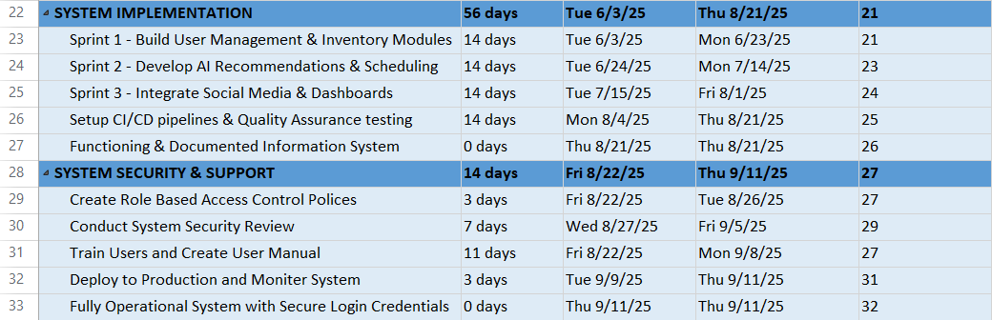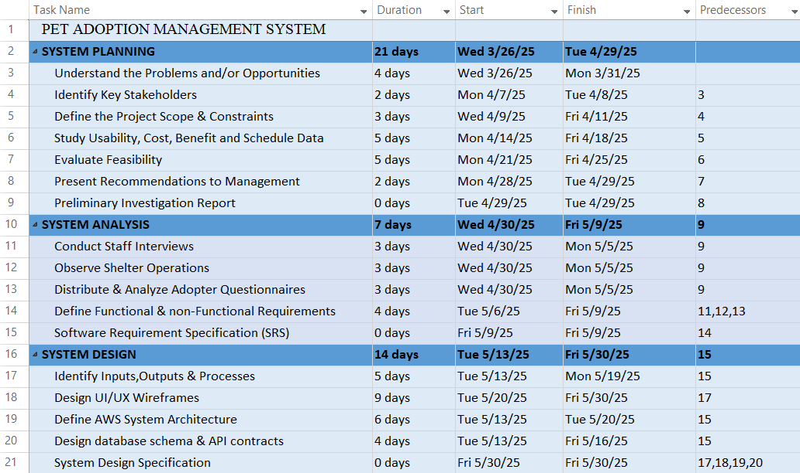

## **3.3** Workload Matrix



|  |  |  |  |  |  |  |
| --- | --- | --- | --- | --- | --- | --- |
| **Area** | **Ahmed TP084807** | **Sultan**  **TP05327** | **Abdallah TP085097** | **Yousef**  **TP085042** | **Mahrus**  **TP085531** | **Sazid**  **TP085531** |
| Introduction | 0% | 0% | 0% | 100% | 0% | 0% |
| Problem & solution | 0% | 0% | 100% | 0% | 0% | 0% |
| Project Planning | 50% | 0% | 50% | 0% | 0% | 0% |
| Feasibility Study | 0% | 0% | 0% | 0% | 50% | 50% |
| Systems Analysis | 0% | 60% | 0% | 40% | 0% | 0% |
| Design Diagram | 50% | 0% | 0% | 0% | 50% | 0% |
| Interface Design | 0% | 50% | 0% | 0% | 0% | 50% |
| **Digital Signature** | **Ahmed** | **STK** | **Abdo** | *MO* | *~~MSA~~* |  |

# CHAPTER 4: FEASIBILITY STUDY

## **4.1** Operational Feasibility

Operational feasibility assesses how well a proposed system supports day-to-day processes, end-user needs, and organizational workflows. It evaluates system performance, usability, control, and alignment with service goals to ensure smooth integration into existing operations with minimal disruption.

### **4.1.1** Performance

The new PAMS system is designed for high performance and consistent reliability, even under heavy user loads. Hosted on AWS, it takes full advantage of auto-scaling features to dynamically allocate computing resources based on real-time demand. Whether the system is handling 20 or 2,000 users, it remains responsive. Peak adoption seasons, community events, or social media-driven traffic spikes are all handled smoothly. Key user actions—like pet browsing, submitting applications, or updating volunteer schedules—are optimized using AWS CloudFront and API Gateway caching to reduce latency. In addition, DynamoDB delivers millisecond response times for querying pet data and adoption history. Lambda functions streamline backend processes to reduce wait times. This ensures that even staff working with multiple modules—pet registration, inventory, or reports—experience fast load times and minimal delays. Continuous performance monitoring using Amazon CloudWatch helps identify and resolve bottlenecks proactively. The system is also tested for concurrent user performance, ensuring staff and adopters never face lag during high-volume periods.

### **4.1.2** Information

PAMS efficiently captures, organizes, and processes all vital shelter information. Each pet has a structured profile including breed, age, vaccination status, temperament, and special needs, all stored in DynamoDB with real-time syncing. Adopter profiles contain lifestyle data, preferences, and adoption history, enabling intelligent recommendations using Amazon Personalize. Volunteer records include availability, task completion, and feedback logs. All data is updated in real-time and centralized in AWS, ensuring consistency and availability across devices. Staff can visualize data through dynamic dashboards in Amazon QuickSight, displaying pet availability trends, medical due dates, and staff activity metrics. System alerts notify of low supplies, overdue tasks, or pets with urgent medical needs. PAMS also logs interaction history—such as who edited a pet profile or responded to an adopter query—for traceability. This structured, integrated information approach enables smarter decision-making and more responsive shelter operations. The system eliminates scattered paper records, giving staff, admins, and volunteers a single source of truth for fast, informed action.

### **4.1.3** Economy

PAMS is cost-effective by design, using serverless AWS services like Lambda, S3, and DynamoDB that bill only for what is used. There is no need for on-premises infrastructure, reducing capital expenditures and ongoing maintenance. The RM 70,000 budget has been allocated to maximize value, covering development, AI features, security, backups, and monitoring tools. The automation of repetitive tasks—like sending reminders, assigning shifts, or updating social media listings—saves hundreds of staff hours annually. Volunteer coordination, pet record updates, and adoption status tracking are streamlined into one digital flow, reducing errors and admin workload. Furthermore, predictive analytics help the shelter forecast demand and allocate resources wisely, preventing overstocking or waste. AWS Budgets and Cost Explorer track usage and spending in real time, ensuring no surprise overages. As the system scales, costs remain predictable and manageable. Over five years, PAMS is projected to deliver significant ROI through operational savings, improved adoption rates, and better resource utilization, while keeping IT overhead minimal.

### **4.1.4** Control

Security and role-based access control are core components of PAMS, ensuring that each user only accesses what is necessary for their role. Admins can define, manage, and audit access privileges using Amazon Cognito and IAM. Shelter staff can update pet records and manage inventory, while volunteers are limited to shift viewing and reporting. Adopters can only access their own applications and browse pet profiles. All authentication processes support multi-factor login for added protection. Data is encrypted both in transit (TLS) and at rest (AES-256), securing sensitive adopter, staff, and animal health data. CloudTrail tracks every critical event—logins, data edits, and role changes—maintaining a transparent and auditable activity trail. Alerts can be configured for unauthorized access attempts, and GuardDuty monitors for suspicious behavior. Security configurations are routinely audited, and any potential vulnerabilities are patched as part of ongoing DevSecOps. These control mechanisms ensure accountability, compliance, and data protection across the platform, essential for maintaining trust and operational continuity.

### **4.1.5** Efficiency

PAMS is built to eliminate inefficiencies common in traditional, paper-based shelter management. Repetitive tasks—such as volunteer shift coordination, application processing, and inventory checks—are now handled through automation. For example, the system assigns tasks to available staff or volunteers based on role and shift data. It also tracks task status in real time, sending alerts when assignments are overdue or skipped. Inventory usage is monitored with automated alerts for low stock or expiring items, helping prevent supply gaps. Adopters can submit documents, schedule visits, and receive pet recommendations without needing staff intervention, freeing up staff time. Predictive maintenance alerts prevent equipment failures by prompting timely servicing. AI-assisted reporting saves hours of manual data analysis, and all system activity is logged for easy reference. Staff spend less time on clerical work and more time on animal care, while volunteers get clear, streamlined access to responsibilities. The system significantly improves overall shelter workflow, response times, and team productivity.

### **4.1.6** Service

PAMS transforms how shelter services are delivered by unifying all critical operations into a centralized platform. Adopters can discover pets, apply online, get AI-based pet suggestions, and track their application progress—all from one interface. Volunteers can view open shifts, sign up, and log tasks, while staff can manage pet records, inventory, and maintenance with ease. Automated reminders ensure no appointments or tasks are missed. For adopters, the experience feels personal—tailored pet matches and proactive communication make them feel supported. For staff, centralized dashboards and reports offer a real-time overview of adoption activity, shelter occupancy, and team performance. The system syncs with third-party platforms like PetFinder and Facebook, instantly updating pet listings to boost visibility and adoption speed. Even after adoption, follow-up forms and care resources are provided digitally to support pet success. This all-in-one approach streamlines operations, reduces friction, and elevates the quality of service for animals, adopters, staff, and the wider community.

## **4.2** Technical Feasibility

Technical feasibility assesses whether the proposed Pet Adoption Management System (PAMS) can be successfully developed and maintained using current technologies, infrastructure, tools, and expertise. It considers compatibility, scalability, technical risks, and whether required hardware, software, and skills are available to support the PAMS solution.

The technology behind the new Pet Adoption Management System (PAMS) is entirely built on the AWS cloud, offering a flexible, scalable, and reliable infrastructure without the need for on-premises servers or hardware upgrades. This cloud-native approach ensures that the system can handle growth effortlessly—from a handful of users to thousands of concurrent adopters, volunteers, and staff.

The backend of PAMS is powered by AWS Lambda, a serverless compute service that dynamically scales based on demand, eliminating the need to manage infrastructure. Amazon S3 is used for securely storing pet images, medical documents, and adopter files, while Amazon DynamoDB provides a fast and reliable NoSQL database for real-time access to adoption records, pet profiles, and scheduling data.

AI-driven pet matching is implemented through Amazon SageMaker, which analyzes adopter preferences, home environment, and interaction history to recommend ideal pet matches. This learning system improves over time, increasing successful adoptions.

Additionally, the platform integrates with social media and third-party adoption websites via APIs managed through Amazon API Gateway, allowing pet listings to be automatically updated without manual effort. Security is managed end-to-end through Amazon Cognito (for role-based user authentication), AWS Web Application Firewall (WAF), and GuardDuty for real-time threat monitoring.

Overall, the chosen AWS architecture ensures PAMS is not only technically feasible but future-proof—easy to maintain, highly available, and designed to support shelter operations with minimal overhead.

## **4.3** Economic Feasibility

Economic feasibility assesses whether a project is financially viable. It analyzes costs, benefits, risks, and potential returns to determine if the investment is worthwhile and sustainable over time. This helps decision-makers avoid unprofitable or financially risky ventures.

To evaluate the economic feasibility of PAMS, we must produce a cost-benefit analysis sheet. Below is an estimate of the expected costs and benefits of the PAMS project:

Costs Table:

|  |  |  |
| --- | --- | --- |
| Category | Estimated Cost (RM) | Details |
| Amazon Web Services (AWS) Cloud Infrastructure | RM 20,000 | Reserved instance pricing (3-years, all upfront) + cloud services (Lambda, S3, RDS, SageMaker, API Gateway, etc.) |
| Development Team (2-3 FTEs, 6 months) | RM 36,000 | Includes full stack devs, Al/ML engineer, project lead |
| Tools, Licenses & APls | RM 4,000 | Includes Mailgun, Twilio, Meta API, calendar integration, and other SaaS tools |
| Support & Operations Setup | RM 6,000 | DevOps support, CI/CD pipeline, infrastructure monitoring |
| Training, Documentation,  Knowledge Transfer | RM 4,000 | Internal staff enablement, AWS skills handoff, user guides,  SOPs |
| Total Project Cost: | RM 70,000 | Fully within the new budget |

Benefits Table:

|  |  |  |
| --- | --- | --- |
| Benefit Area | Estimated Annual Value (RM) | Description |
| Operational Efficiency | RM 30,000 | Reduction of manual scheduling, asset tracking, inventory checks (~2 FTE hours/day saved) |
| Higher Pet Adoption Rates | RM 30,000 | Al-driven matchmaking, social media automation, faster listing updates (+20-30% more adoptions/year) |
| Reduced Equipment Downtime | RM 5,000 | Predictive maintenance and real-time alerts reduce costs for repairs and replacements |
| Better Volunteer Management | RM 8,000 | Calendar syncing, task assignments, and automated notifications increase attendance and reduce no-shows |
| Waste Reduction | RM 3,000 | Inventory expiry tracking and digital waste monitoring reduce medication/supply losses |
| Improved Reporting | RM 2,000 | Quicker decision-making via real-time dashboards and alerts (less time spent in manual data analysis) |
| Total Estimated Annual Value: | RM 78,000 | Combined impact of all improvements delivers measurable cost savings, efficiency gains, and outcomes |

Estimated ROI:

Formula:

ROI = (Total Benefits - Total Costs) / Total Costs

ROI = (RM 78,000 - RM 70,000) / RM 70,000 = ~11.4% (Year 1)

This estimate is well within budget, especially considering the system is now live and most of the one-time development cost is already covered. For subsequent years, the only recurring major costs will be AWS usage, ops support, and optional tool subscriptions.



Total Estimated Annual Operating Cost:

|  |  |  |
| --- | --- | --- |
| Category | Estimated Annual Cost (RM) | Notes |
| AWS Cloud Infrastructure | RM 16,500 | Reserved instances and usage-based services (includes compute, storage, Al, API usage, database, CloudFront, QuickSight) |
| System Support & Maintenance | RM 12,000 | DevOps + security monitoring, patching, backups, and system health management (RM 1,000/month) |
| Third-party API/Tool Licenses | RM 2.000 | Services like Mailgun (email), Twilio (SMS), Meta API access, calendaring |
| Monitoring & Security Tools (optional add-ons) | RM 1,500 | Additional budget for AWS Security Hub, GuardDuty, or third-party alerts (optional) |
| Total Annual Operating Cost: | RM 32,000 | Sum of all infrastructure, support, tools, and training costs required to operate the system annually |

ROI Over Subsequent Years:

|  |  |  |  |  |
| --- | --- | --- | --- | --- |
| Year | Annual Operating Cost (RM) | Benefits (RM) | Estimated ROI (%) | Net Gain (RM) |
| Year 2 | RM 32,000 | RM 78,000 | 143.75% | RM 46,000 |
| Year 3 | RM 32,000 | RM 78,000 | 143.75% | RM 46,000 |
| Year 4 | RM 32,000 | RM 78,000 | 143.75% | RM 46,000 |
| Year 5 | RM 32,000 | RM 78,000 | 143.75% | RM 46,000 |

Summary**:**

* **Break-even point** is reached within **Year 1** if we include both development and operations.
* From **Year 2 onward**, you generate a **net gain of RM 46,000 per year**.
* Over **5 years**, the system could yield a **total net benefit of RM 184,000**, not including potential gains from adopter growth, operational efficiencies, or cost reductions through scaling.

## **4.4** Schedule Feasibility

Schedule feasibility evaluates whether a project can be completed within a specific timeframe. It considers deadlines, resource availability, task durations, and potential delays to ensure the timeline is realistic and achievable, helping to prevent time overruns and missed targets.

The **PAMS system development** follows a structured Agile approach over **14 working weeks**, which translates to **approximately 5 months and 17 days**. This schedule fits within the allocated 6-month development timeframe, offering a buffer of **13 days early** completion. This early delivery advantage increases project flexibility for post-launch adjustments, stakeholder walkthroughs, or scope enhancements without compromising the original deadline.

Here is the Schedule Feasibility breakdown in weeks:

|  |  |
| --- | --- |
| Weeks | Task |
| Weeks 1-6 | Requirements Finalization, Architecture Design, PoC for Core Modules (Compute + Storage + RBAC) |
| Weeks 7-8 | **Development Sprint 1** - Core Modules: Adoptions, Volunteer Scheduling, Inventory & Asset Management |
| Weeks 9-10 | **Development Sprint 2** - Al Recommendation Engine + Predictive Maintenance |
| Weeks 11-12 | **Development Sprint 3** - Integration: Social Media APIs, 3rd-Party Listings, Dashboard Reporting |
| Week 13 | Testing Phase: CI/CD Pipeline Setup, User Acceptance Testing (UAT), Security Hardening |
| Week 14 | Final Deployment on AWS, Staff Training, Go-Live, Documentation Handoff |

**Note**: Each sprint is assumed to follow a 2-week cycle, with continuous integration and overlapping QA cycles. Parallelization between development and early-stage testing is built into this structure for efficiency.

# CHAPTER 5: SYSTEM ANALYSIS

## **5.1** Functional Requirements

The functional requirements of PAMS focus on automating and optimizing critical pet shelter operations including pet intake, medical care, volunteer coordination, and adoption management, while delivering insights through predictive analytics and ensuring secure, role-based access.

**1. Centralized Digital Intake and Adoption System**

This system should allow shelter staff to register new animals digitally, capturing key information such as species, breed, age, medical history, and behavioral notes. It will also handle the full adoption lifecycle—from application submission to screening, approvals, scheduling meet-and-greets, and finalizing adoption agreements. Adopters can view real-time pet availability and receive personalized suggestions. The centralized nature of this system ensures that all pet records and adoption interactions are stored consistently and can be easily retrieved.

**2. Medical Record System**

PAMS will maintain a digital medical history for each animal, including vaccination records, surgical notes, treatment schedules, allergies, and dietary restrictions. Shelter staff and partner vets can securely update and access these records. The system should support document uploads (e.g., scan reports), automate reminders for upcoming vaccinations or treatments, and track chronic health conditions. This feature ensures better healthcare tracking and continuity of care for all animals in the shelter.

**3. Smart Task Scheduling System**

A built-in scheduling engine will help assign tasks such as feeding, cleaning, medical checkups, and grooming based on staff or volunteer availability. This system should allow for recurring tasks, shift planning, real-time task assignment, and automated reminders. Predictive workload estimation (based on pet count and shelter activity trends) will help shelter managers optimize workforce distribution and reduce missed duties.

**4. Digital Volunteer and Donor Management Module**

Volunteers can register, select roles, view upcoming tasks, and log hours through an interactive portal. Staff can assign shifts, monitor attendance, and gather feedback. For donors, the system should track donation history, issue digital receipts, and automate thank-you messages. Integration with email and calendar systems will ensure that volunteers and donors remain engaged and well-informed, strengthening community relationships and operational efficiency.

**5. Predictive Analytics Dashboard**

PAMS will feature a real-time dashboard displaying actionable insights such as adoption trends, pet stay duration, volunteer attendance, and resource usage. Powered by machine learning, the dashboard can forecast supply shortages, peak adoption seasons, or staff workload bottlenecks. This visibility will support data-driven decision-making, help anticipate challenges, and improve overall shelter performance.

**6. Asset Tracking System**

This module will monitor the usage, location, and maintenance status of shelter equipment—such as kennels, washing stations, grooming tools, and medical devices. Integration with QR codes or RFID tags will enable real-time tracking and fast check-ins/check-outs. Staff will receive alerts for scheduled servicing, warranty expiration, or misplaced assets. This prevents equipment loss, extends asset life, and ensures operational readiness.

**7. Digital Waste Management Tool**

To promote eco-conscious practices, this tool will log and track waste disposal frequency, types (e.g., food, medical, general), and volume. Staff can input daily disposal logs, receive alerts for irregular waste patterns, and generate reports for regulatory compliance or sustainability audits. The system may also support tracking recycling or composting efforts, helping the shelter reduce environmental impact.

**8. Role-Based Access Control and Secure Data Storage**

All users will access PAMS based on predefined roles—Admin, Staff, Volunteer, Adopter—with different data visibility and action permissions. Admins can assign roles and modify privileges. Sensitive information, such as adopter documents or animal health records, will be encrypted and stored securely using AWS services like Cognito, IAM, and S3. Logs of user activity will be maintained for audit and compliance purposes. This structure ensures both data privacy and operational security across the platform.

## **5.2** Non-Functional Requirements

PAMS non-functional requirements ensure high system performance, security, scalability, and usability. The platform guarantees reliability, regulatory compliance, easy maintenance, and seamless user experience across roles, with secure, auditable access to sensitive pet and user data.

**1. Performance**

PAMS must deliver a responsive user experience with a system response time of under 2 seconds for 98% of user actions, including viewing pet profiles, submitting applications, and updating tasks. It should support up to 5,000 concurrent users during high-traffic periods such as adoption campaigns. Background operations like analytics generation or scheduled tasks must not affect user-facing performance. System latency should be minimized across all devices—desktop, tablet, and mobile. Backend functions (API calls, database queries) should be optimized for low overhead, especially for modules like the AI recommendation engine and inventory updates.

**2. Reliability and Availability**

PAMS should maintain a minimum of 99.99% uptime, ensuring that users—including adopters and shelter staff—can access the system reliably without disruptions. The platform must be fault-tolerant and recover gracefully from server or network failures. Services must be deployed across multiple Availability Zones to ensure continuity during unexpected infrastructure outages. All user interactions, especially application submissions and pet health updates, must be transactionally safe—data must never be lost or duplicated due to system crashes. Scheduled maintenance windows should be minimal and communicated in advance, with failover procedures ensuring service continuity during upgrades or recovery.

**3. Scalability**

PAMS must be designed to scale both horizontally and vertically. As the number of adopters, volunteers, and pets increases, the system should seamlessly expand to handle new traffic, workloads, and data volume. Services like pet listing, analytics dashboards, and AI matching must be able to scale independently using serverless architecture or container orchestration (e.g., AWS Lambda, Fargate). PAMS should scale automatically during high-demand periods (e.g., nationwide adoption drives) and downscale when idle to optimize cost. Database read/write throughput must scale with growing records, and third-party integrations should not bottleneck the main application workflow.

**4. Usability**

PAMS must offer a clean, intuitive, and accessible interface for all user roles, including adopters, volunteers, shelter staff, and administrators. Interfaces should follow standard UX principles with logical navigation, clear feedback messages, and accessible forms. Tasks such as browsing pets, scheduling a visit, or logging volunteer hours should require minimal clicks and effort. The system should be mobile-responsive and accessible to users with disabilities, adhering to WCAG 2.1 Level AA standards. Users should be able to onboard with minimal training, and helpful tooltips, search filters, and validation prompts should guide them throughout their workflows.

**5. Security and Compliance**

PAMS must enforce strict security protocols to protect sensitive information such as adopter identity, medical records, and internal shelter data. All communication must be encrypted via HTTPS/TLS. Access control will be enforced using role-based policies (RBAC) powered by Amazon Cognito and AWS IAM. Sensitive data in storage, including medical documents and adoption forms, must be encrypted using AES-256. The system should comply with relevant data protection regulations like GDPR and HIPAA, ensuring user consent for data collection and offering data removal on request. Threat detection (via AWS GuardDuty) and audit logging (via CloudTrail) must be implemented.

**6. Maintainability**

PAMS should be built using modular, loosely coupled components to simplify maintenance and future upgrades. The system architecture must follow microservices or serverless design patterns to isolate faults and allow individual services to be updated independently. Clear versioning of APIs and dependencies should be maintained, and environment-specific configurations (e.g., dev, test, prod) must be externalized. Infrastructure as Code (IaC) using AWS CloudFormation or CDK will ensure consistent deployments. Detailed internal documentation should be provided to reduce reliance on developers and enable smooth transitions for new IT support staff.

**7. Auditability and Transparency**

All critical system actions—logins, data updates, deletions, permission changes—must be logged and made auditable. These logs must be immutable, time-stamped, and securely stored for at least 12 months. Admins should be able to query, filter, and export audit logs through a dedicated dashboard for internal reviews or compliance audits. For example, actions like editing pet profiles, approving adoptions, or modifying user roles should be traceable to specific users.

## **5.3** Architecture Requirements

The architecture of the Pet Adoption Management System (PAMS) must be modern, secure, scalable, and cloud-native—built entirely on the AWS ecosystem to support efficient, real-time operations across adopters, volunteers, staff, and administrators. Below are the comprehensive architectural requirements, categorized for clarity and aligned with the functional and non-functional goals of the project.

**1. Cloud-Native Architecture**

* The entire system must be deployed on Amazon Web Services (AWS**)** using fully managed services to avoid hardware provisioning and manual server management.
* The architecture should follow a microservices or serverless model, allowing independent scalability of features like pet listings, volunteer scheduling, and the recommendation engine.
* Application layers (frontend, backend APIs, AI services, storage, analytics) must be decoupled using event-driven or API-based integrations for better performance and maintainability.

**2. Web-Based and Mobile-Responsive UI**

* The user interface must be accessible through any modern browser and optimized for mobile devices, allowing adopters, staff, and volunteers to access services on the go.
* Built using React.js, Vue.js, or similar front-end frameworks, and hosted via Amazon Web Services for static content delivery and low-latency access.

**3. Serverless Compute Layer**

* The backend must be developed using AWS, orchestrated through Amazon API Gateway, supporting RESTful APIs for modular interaction with various services (e.g., user authentication, pet profiles, inventory updates).
* Lambda functions must support integration with Amazon DynamoDB, Amazon S3 Simple Storage Solution.

**4. Scalable Data Storage & Management**

* Pet records, adoption history, and scheduling data must be stored in Amazon DynamoDB for fast, scalable NoSQL access.
* Binary files like pet images, vaccination scans, and adopter documents must be stored in Amazon S3, with access restricted via IAM roles and URLs expiring by default.
* Logs, reports, and archival data should leverage Amazon S3 Glacier for long-term storage at lower cost.

**5. AI/ML Recommendation Engine**

* Pet-Adopter matching must be powered by Amazon Personalize, trained on structured data such as adopter profiles, lifestyle preferences, and adoption history.
* The architecture must allow the recommendation engine to be modular, so future enhancements (e.g., video interaction feedback) can be integrated.

**6. Authentication and Authorization**

* Identity and access management must be handled by Amazon Cognito, supporting multi-factor authentication, social login (Google, Facebook), and role-based access control (RBAC) for Admins, Shelter Staff, Volunteers, and Adopters.
* Fine-grained access permissions must be enforced using AWS IAM roles and policies.

**7. Real-Time Monitoring, Logging, and Alerts**

* All critical actions (login, pet updates, role changes) must be logged via AWS CloudTrail.
* System health, API performance, and application logs must be monitored via Amazon CloudWatch, with alarms configured for high latency or error rates.
* AWS Web Application Firewall (WAF) must be integrated to detect and mitigate threats (e.g., brute force attacks, SQL injection attempts).

**8. CI/CD and DevOps Automation**

* Continuous Integration/Deployment should be managed using AWS CodePipeline for reliable deployments and rollbacks.
* Infrastructure provisioning and changes should be controlled using AWS Cloud Development Kit (CDK) to ensure repeatability and governance.

**9. API Integrations**

* The architecture must support external API integrations with platforms like PetFinder, Facebook, Instagram, and veterinary record systems.
* APIs should be exposed via Amazon API Gateway, secured with Cognito authorizers, and throttled to prevent abuse.

**10. Disaster Recovery and High Availability**

* All critical data must be automatically backed up using AWS Backup and stored redundantly across multiple Availability Zones (multi-AZ).
* The platform must support high availability through multi-AZ deployment strategies, including auto-healing components and failover configuration.
* AWS Elastic Disaster Recovery (AWS DRS) must be implemented to restore critical systems in the event of a service outage.

**11. Data Privacy & Compliance**

* All personal and sensitive data must comply with GDPR and HIPAA where applicable.
* Data classification, scanning, and privacy monitoring must be handled using Amazon Macie Threat Detection to ensure data protection and audit readiness.

## **5.4** Business Requirements

The business requirements of PAMS focus on streamlining pet shelter operations by digitizing adoption workflows, automating scheduling, enhancing user engagement, and improving decision-making. The system supports scalability, real-time data access, secure user roles, and integration with external platforms.

**1. Centralize Shelter Operations**

* Replace fragmented and paper-based processes with a single digital platform that supports pet registration, adoption, volunteer coordination, donor tracking, and inventory management.
* Reduce redundancy and human error in data entry and task execution.

**2. Improve Adoption Experience**

* Offer adopters a self-service portal where they can browse pets, apply online, and track their application status in real time.
* Use AI-driven recommendations to match pets with suitable adopters based on lifestyle, home environment, and previous interactions.
* Enable automated follow-ups post-adoption to ensure successful pet placement and gather feedback.

**3. Enhance Staff and Volunteer Productivity**

* Provide shelter staff with tools for scheduling tasks, updating pet records, and managing adopter communications efficiently.
* Allow volunteers to register, select shifts, log hours, and receive task assignments via a unified portal with calendar integration.
* Automate reminders and alerts to prevent missed appointments or overdue care routines.

**4. Enable Predictive & Real-Time Decision-Making**

* Deliver predictive analytics dashboards for management to monitor adoption trends, identify bottlenecks, and forecast inventory or staffing needs.
* Generate real-time reports and alerts on pet health, task completion, volunteer activity, and resource usage to support informed decisions.

**5. Optimize Resource & Asset Management**

* Implement automated inventory tracking with alerts for low stock, expiry dates, and restocking needs.
* Deploy an asset tracking module to monitor location and maintenance status of shelter equipment using QR or RFID tagging.
* Introduce a waste management tool to log, analyze, and reduce waste across the shelter through data-driven sustainability practices.

**6. Ensure Role-Based Security & Compliance**

* Enforce role-based access control (RBAC) so that users only see what is relevant to their role (Admin, Shelter Staff, Volunteer, Adopter).
* Protect sensitive data (e.g., adopter identity, medical records) using encryption, MFA, and regular activity logging.
* Meet data compliance requirements (GDPR, HIPAA) with built-in auditability and secure cloud storage practices.

**7. Improve Outreach & Pet Visibility**

* Automatically sync pet profiles to adoption websites and social media platforms to increase visibility and adoption chances without duplicating staff effort.
* Enable campaign tracking and outreach analytics to understand which platforms generate the most engagement.

**8. Support Long-Term Growth and Innovation**

* Build the system with scalability in mind, allowing Pet4U to serve more users, onboard more pets, and expand to new locations without major changes.
* Lay a foundation for future enhancements such as mobile apps, live video adoption calls, chatbot support, and integration with nationwide shelter networks.

## **5.5** System / Technical Requirements

The Pet Adoption Management System (PAMS) is a modern, cloud-native platform built on Amazon Web Services (AWS), designed to meet the operational needs of animal shelters through automation, security, and smart integrations. The following system and technical requirements ensure its success across infrastructure, software, networking, data, Artificial Intelligence (AI), and Development Operations (DevOps).

**1. Infrastructure Requirements**

* Cloud Hosting**:** Full deployment on AWS (Amazon Web Services) using managed services to eliminate the need for physical servers.
* Compute: Use AWS Lambda (PaaS) or Amazon Elastic Container Service (ECS) for containerized services that auto-scale.
* Storage**:** Use Amazon S3 (Simple Storage Service) for pet photos, adopter documents, reports, and Amazon S3 Glacier for long-term data archival.
* Database**:** Use Amazon DynamoDB for NoSQL real-time data (pet records, applications, scheduling), and Amazon RDS (PostgreSQL) for structured reporting needs.

**2. Security & Compliance**

* Authentication**:** User identity managed via Amazon Cognito, with multi-factor authentication (MFA).
* Authorization**:** Fine-grained Role-Based Access Control (RBAC) using Identity and Access Management (IAM) roles for Admin, Staff, Volunteer and Adopter.
* Encryption**:** Data encrypted in transit using Transport Layer Security (TLS) and at rest with Advanced Encryption Standard (AES-256).
* Audit Logs**:** Track all user activity via Amazon CloudWatch Logs.
* Compliance**:** Ensure GDPR and HIPAA compliance with Amazon Macie for data classification and privacy.

**3. Artificial Intelligence & Machine Learning Capabilities**

* Recommendation Engine**:** Implement Amazon Personalize to suggest pet matches based on adopter profiles and behavioral data.
* Predictive Maintenance**:** Optional IoT/AI module using equipment logs to forecast servicing needs.

**4. Application Layer**

* Front-end**:** Developed using React.js and hosted via AWS CloudFront.
* Mobile-Friendly**:** Fully responsive design for tablet and mobile access by all user roles.
* API Gateway**:** All services exposed via Amazon API Gateway, enforcing rate limits, and secured with Cognito authorizers.

**5. Integration Requirements**

* Social Media Integration**:** Auto-sync listings with Facebook, Instagram, and PetFinder via APIs.
* Volunteer Tools**:** Integration with Google Calendar API for shift syncing.
* Third-party APIs**:** Secure token-based access for vets, donors, or local municipal pet registries.

**6. Analytics & Reporting**

* Dashboards**:** Use Amazon QuickSight to create real-time visualizations of adoptions, inventory, tasks.
* Alerts**:** Notification system using Amazon Simple Notification System (SNS) and Amazon Simple Email Service (SES) for reminders, alerts, and announcements.
* Logging & Monitoring**:** Use Amazon CloudWatch, AWS GuardDuty, and AWS Config for health checks and anomaly detection.

**7. CI/CD & DevOps**

* Code Management**:** Integrated with GitHub.
* Deployment Pipeline**:** CI/CD via AWS CodePipeline, CodeBuild, and CodeDeploy with environment segmentation (dev, staging, prod).
* Infrastructure as Code (IaC)**:** Use AWS Cloud Development Kit (CDK) for consistent deployments.
* Rollback Support**:** Enable rollback triggers on failed deployments.

**8. Network & Availability**

* DNS Routing**:** Managed using Amazon Route 53.
* Virtual Private Cloud (VPC) Architecture**:** Isolate components in private/public subnets for security.
* Availability Zones**:** Deployed across multiple AZs to ensure 99.99% uptime.
* Load Balancing**:** Use Application Layer Balancer (ALB) and Network Layer Balancer (NLB) for distributing requests across microservices.

PAMS's technical framework is designed for resilience, speed, automation, and scalability. It ensures that animal shelters using the platform can operate efficiently, securely, and grow with demand—while remaining cost-effective and future-ready.

## **5.6** User Requirements

**1. Admin (Shelter Management)**

**Role**: Supervisors and decision-makers overseeing shelter operations, staff, and overall system performance.

**User Requirements**:

* Access to a centralized administrative dashboard to view shelter metrics: pet availability, adoption rates, volunteer hours, and equipment status.
* Generate automated reports and analytics, including trends (e.g., peak adoption periods) and predictive alerts (e.g., low inventory, maintenance scheduling).
* Manage role-based permissions for shelter staff, volunteers, and adopters to enforce least privilege access.
* Approve or override pet listings, volunteer assignments, and scheduled tasks.
* Initiate and monitor data backups, recovery processes, and system integrity checks.
* View system audit trails, track user activity logs, and ensure compliance with privacy standards (e.g., GDPR, HIPAA).
* Monitor third-party integration status (e.g., pet listing platforms, social media sync).

**2. Shelter Staff**

**Role**: Operate and manage daily shelter workflows including pet care, appointments, and adopter interactions.

**User Requirements**:

* User-friendly portal to add, update, or retire pet profiles, with support for uploading images, medical records, behavior notes, and status.
* Smart scheduling tools for managing visits, medical checkups, and maintenance tasks—integrated with calendars and reminders.
* Integrated adopter database for quick retrieval of communication logs, application status, and preferences.
* Notifications and task alerts (e.g., vaccination due, follow-up call reminder).
* Access to inventory dashboards for food, medicine, and equipment—receive alerts when stock levels drop or items near expiry.
* Ability to tag or flag pets for special needs, behavioral watch, or featured adoptions.
* Report incidents or flag system issues to admin or technical team.

**3. Volunteers**

**Role**: Provide non-salaried support for pet care, cleaning, events, and community outreach.

**User Requirements**:

* Volunteer scheduling portal to view shifts, sign up for open slots, and request time off linked with email and mobile notifications.
* View assigned tasks per shift (e.g., cleaning, feeding, training assistance).
* Log completed tasks and received performance feedback or badges.
* Communicate securely with shelter staff through an in-system chat or bulletin.
* Access basic pet records for caregiving duties (view-only: no edit permissions).
* Submit feedback or incident reports directly to admins for improvements or alerts.
* Training resources and onboarding materials available through an integrated learning portal.

**4. Adopters**

**Role**: Browse, apply for, and adopt pets from the shelter. Interact digitally with shelter staff during and after the adoption process.

**User Requirements**:

* Account registration to manage adoption applications, view status updates, and bookmark pets of interest.
* Intelligent search filters by species, breed, gender, size, temperament, age, etc.
* AI-driven pet match recommendations based on adopter lifestyle, home environment, and preferences.
* Online submission of adoption applications with document upload (e.g., ID, lease agreement, vet references).
* Schedule visits via smart calendar with confirmation and reminders.
* Notifications via email or SMS for application updates, new pet arrivals, or events.
* Post-adoption support with access to pet care resources and follow-up forms.
* Option to submit feedback or flag issues related to adopted pets for further assistance.

**5. Donor**

**Role:** Individuals or organizations who contribute financial or in-kind support to sustain the shelter’s operations, animal care, and development initiatives**.**

**User Requirements:**

* A secure and user-friendly donation portal to make one-time or recurring contributions, with options to choose specific causes (e.g., medical care, food, facility upgrades).
* Profile management to view donation history, download receipts, and update contact or billing information.
* Automated generation of tax receipts and digital acknowledgments for each transaction.
* Access to impact reports or dashboards showing how donations were used (e.g., number of pets treated, supplies purchased).
* Option to receive thank-you messages, badges, or donor highlights via email or social media recognition (opt-in based).
* Ability to subscribe to or opt out of newsletters, fundraising campaigns, or event invites.
* Integration with secure payment gateways supporting credit cards, bank transfers, and e-wallets.
* Transparent privacy and data use policy, ensuring that donor information is protected and not shared without consent.

## **5.7** Security Requirements

**1. User Authentication**

PAMS must implement secure user authentication to protect user accounts and sensitive pet adoption data. Each user—including adopters, volunteers, staff, and admins—should register using a unique login with a strong password. These credentials must be stored securely with encryption to prevent unauthorized access. In the context of PAMS, this means an adopter applying for a pet should not be able to view internal shelter data, and staff should not have access to admin-level controls unless permitted.

**2. Role-Based Access Control (RBAC)**

In a shelter system like PAMS, each user type—adopter, volunteer, shelter staff, and admin—should have a clearly defined set of permissions. For example, adopters should only be able to view available pets and submit applications, while admins need full access to manage records, users, and reports. RBAC ensures sensitive operations (e.g., approving adoptions or managing medical records) are performed only by authorized personnel.

**3. Audit Logging & Monitoring**

A critical requirement for PAMS is to track and log all significant user activities, such as login attempts, record changes, and data exports. This helps in identifying unusual activity (e.g., unauthorized access attempts) and aids compliance with security audits. For example, if an admin deletes a pet profile or changes adopter status, a traceable log should be available for investigation or reporting.

**4. Data Privacy Compliance**

Because PAMS handles personally identifiable information (PII) from adopters and staff (e.g., names, addresses, and contact info), it must comply with data protection regulations like GDPR or HIPAA. Users should be informed of what data is collected and why, and consent must be captured appropriately. For instance, adopters must agree to share home environment details before submitting applications.

**5. Backup & Disaster Recovery**

To ensure PAMS remains resilient to data loss, accidental deletion, or cyber-attacks, all pet data, user information, and system settings must be regularly backed up. A disaster recovery plan must also exist to restore services with minimal downtime if an incident occurs (e.g., fire at the shelter’s server room or ransomware attack).

**6. Firewall & Malware Protection**

Since PAMS is a public-facing system, it must be protected from cyber threats such as malware, SQL injection, DDoS attacks, and bot traffic. This is essential to prevent service disruption or unauthorized access. For example, bots scraping pet data or brute-force login attacks could compromise system integrity.

These comprehensive security layers ensure that PAMS not only protects user and pet data, but also meets industry standards for availability, compliance, and trust—critical for building confidence among adopters, volunteers, and shelter staff.

## **5.8** User Interface Requirements

### **5.8.1** Administrator

**Input Interfaces:**

* Dashboard filters: date range, location, user role.
* Pet registration override/edit forms.
* Staff/Volunteer scheduling tool.
* System settings & role-access configuration.
* Budget/resource allocation forms.
* Bulk upload for pet data (CSV/Excel).
* Report generation input (e.g., filter by species, duration).

**Output Interfaces:**

* Analytics Dashboard: Pet status summary, adoption rates, volunteer hours.
* System Health Status: Alerts from CloudWatch (via SNS).
* Exportable Reports: Inventory, maintenance logs, volunteer activity.
* Access Logs: Via AWS CloudTrail UI integration.
* Audit Trails: Login, CRUD events (user & data).

### **5.8.2** Shelter Staff

**Input Interfaces:**

* Pet Entry Form: Name, breed, age, health status, vaccination records (file upload), temperament.
* Inventory Update Form: Items received, quantity, expiry date.
* Task Scheduler: Daily/weekly tasks, vet appointments, feeding/cleaning logs.
* Adoption Review Panel: Accept/decline adopters with notes.
* Incident Reporting: Notes/photos on pet behavior or health issues.

**Output Interfaces:**

* Pet Roster View: Search/filter by availability, species, age, etc.
* Inventory Dashboard: Low stock alerts, expiry warnings.
* Adoption Queue: Pending applications, flagged adopters.
* Task Calendar View: Shift-based task board.
* Maintenance Alerts: Triggered by predictive analytics.

### **5.8.3** Volunteers

**Input Interfaces:**

* Availability Form: Days/hours they are free to volunteer.
* Task Acceptance Form: Opt-in to specific shelter duties.
* Incident Log: Optional feedback after shifts (issues, notes).
* Training Acknowledgment: Checkbox confirmation post-onboarding.

**Output Interfaces:**

* Personal Dashboard: Upcoming tasks, past logged hours.
* Training Tracker: Progress & required courses/modules.
* Schedule View: Assigned shifts and reminders.
* Pet Info Viewer: Limited view-only access to pet profiles.

### **5.8.4** Adopter Interface

**Input Interfaces:**

* Pet Preference Questionnaire: Home environment, past experience, pet types preferred.
* Adoption Form: Identity verification, references, vet preference.
* Post-Adoption Feedback Form: Pet adjustment feedback, photos.
* AI Matching Consent: Allow system to personalize suggestions.
* Chat/Inquiry Panel: Submit questions or request callback.

**Output Interfaces:**

* Recommended Pets List: AI-driven suggestions (via SageMaker/Personalize).
* Pet Profiles: Searchable listings with photos, health, and availability.
* Application Status Tracker: View current position in adoption pipeline.
* Post-Adoption Resources: Guides, vaccination reminders, vet contacts.

### **5.8.3** Donor Interface

**Input Interfaces:**

* Donation form (amount, frequency, purpose).
* Contact and billing details
* Feedback form for donation campaigns.

**Output Interfaces:**

* Donation confirmation and receipt
* Acknowledgment certificate or badge (for recurring donors).
* Dashboard showing donation impact (e.g., food purchased).

# CHAPTER 6: DESIGN DIAGRAM

## **6.1** System Context Diagram (SCD)

Figure shows a High Level Overview of PAMS

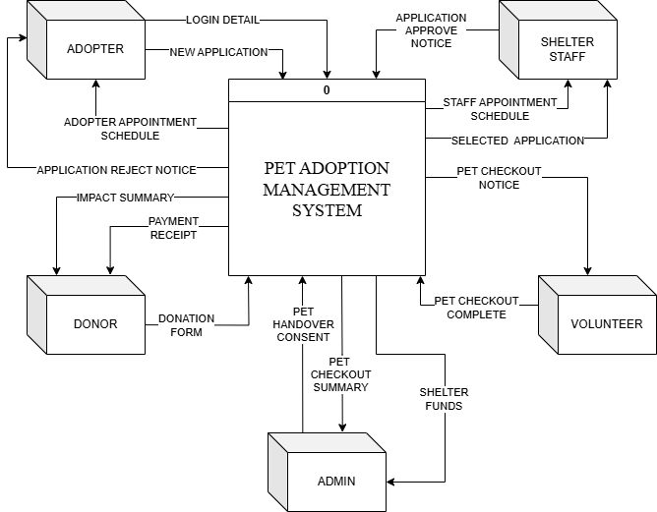

## **6.2** Data Flow Diagram (DFD-Level 0)

Figure 3 show DFD Level 0 of Pet Adoption Management System (PAMS)

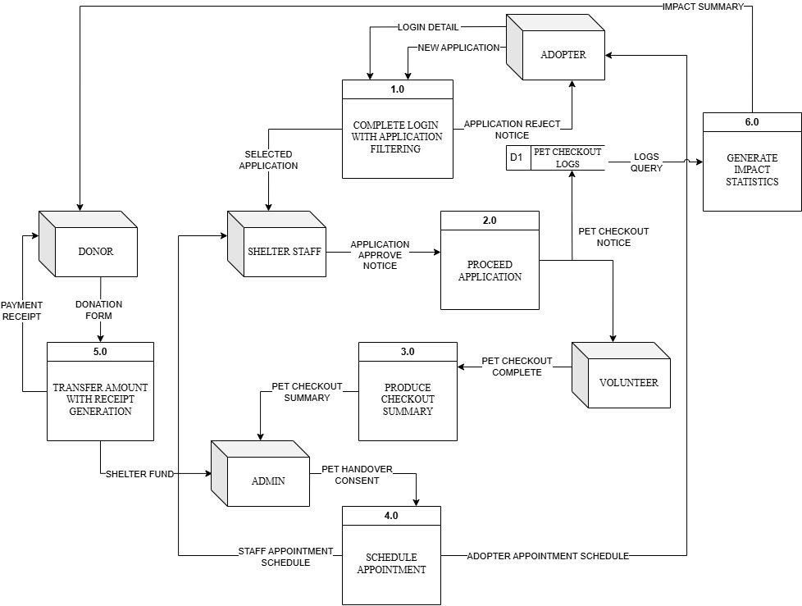

## **6.3** Entity Relationship Diagram (ERD)

Figure 4 shows an ERD Diagram of Pet Adoption Management System (PAMS)

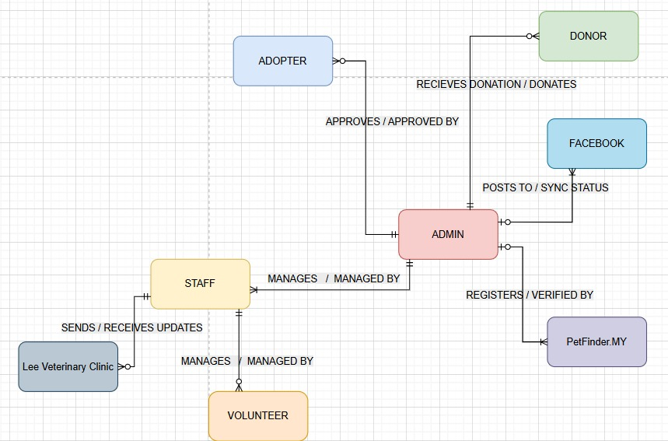

# CHAPTER 7: INTERFACE DESIGN

## **7.1** Adopter Interface

### **7.1.1** Input Interface

Figure 5: Homepage

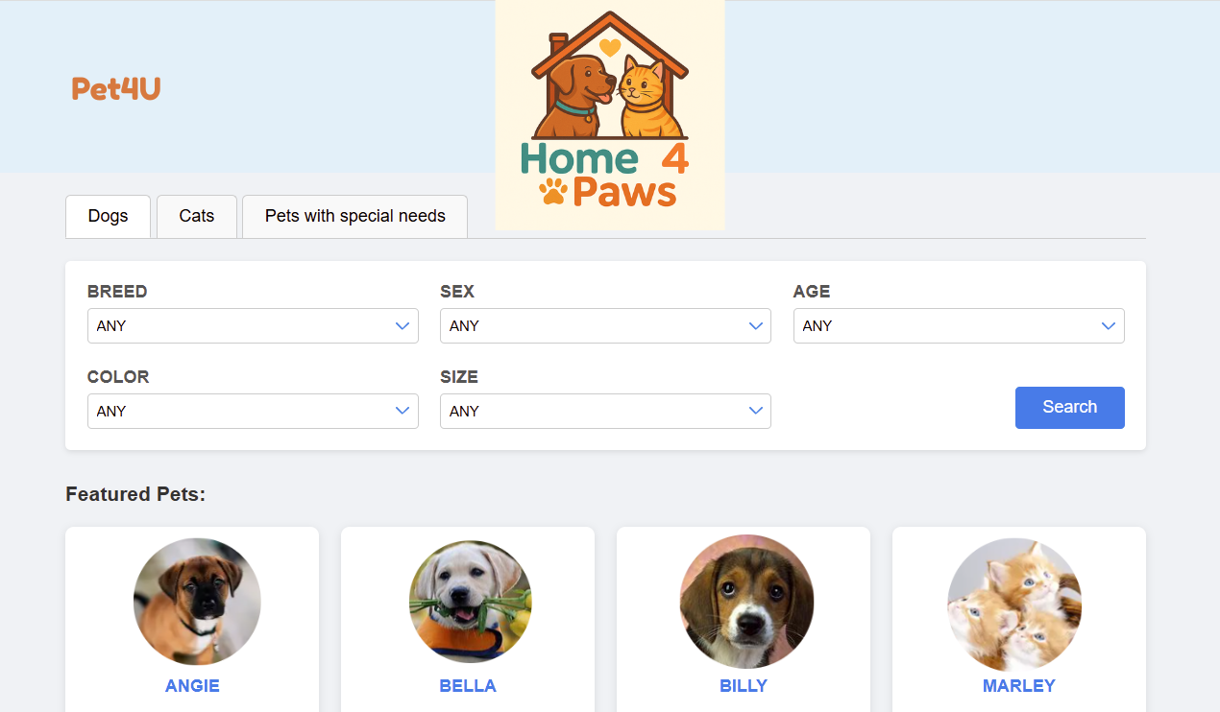

Figure 6: Login page

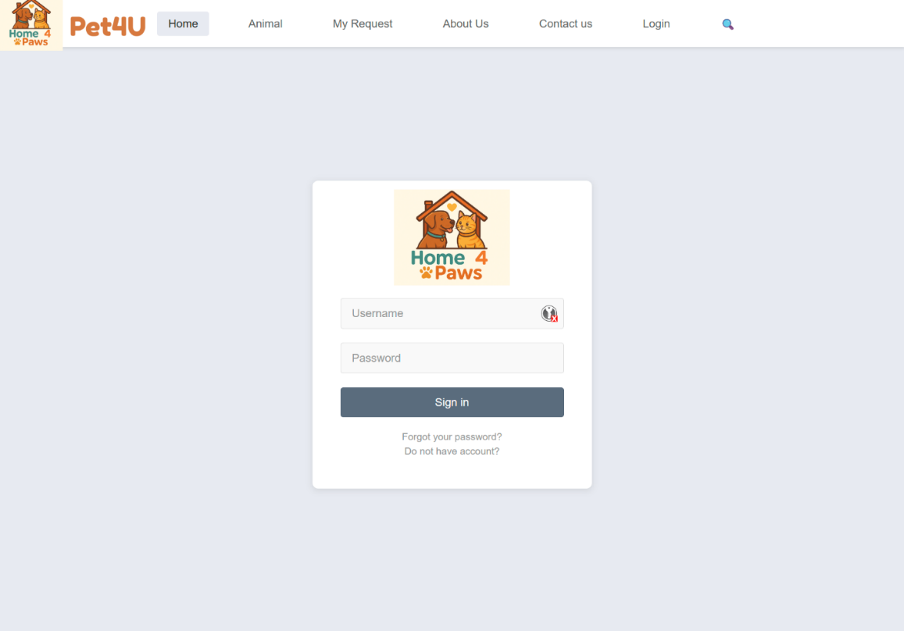

Figure 7: Sign Up page

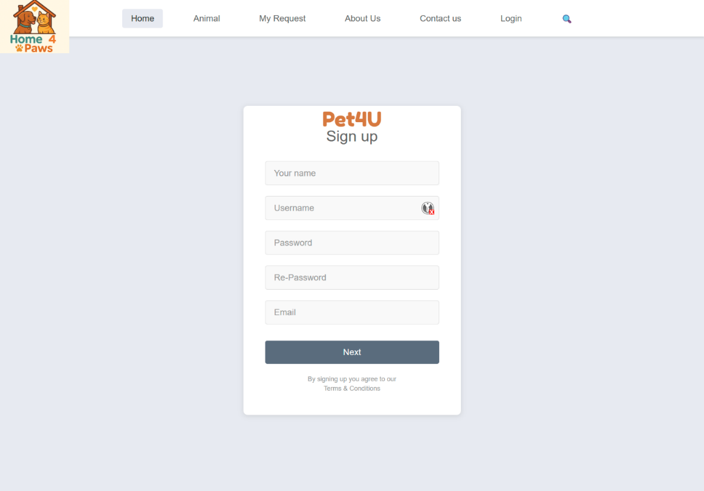

Figure 8: Questionnaire form

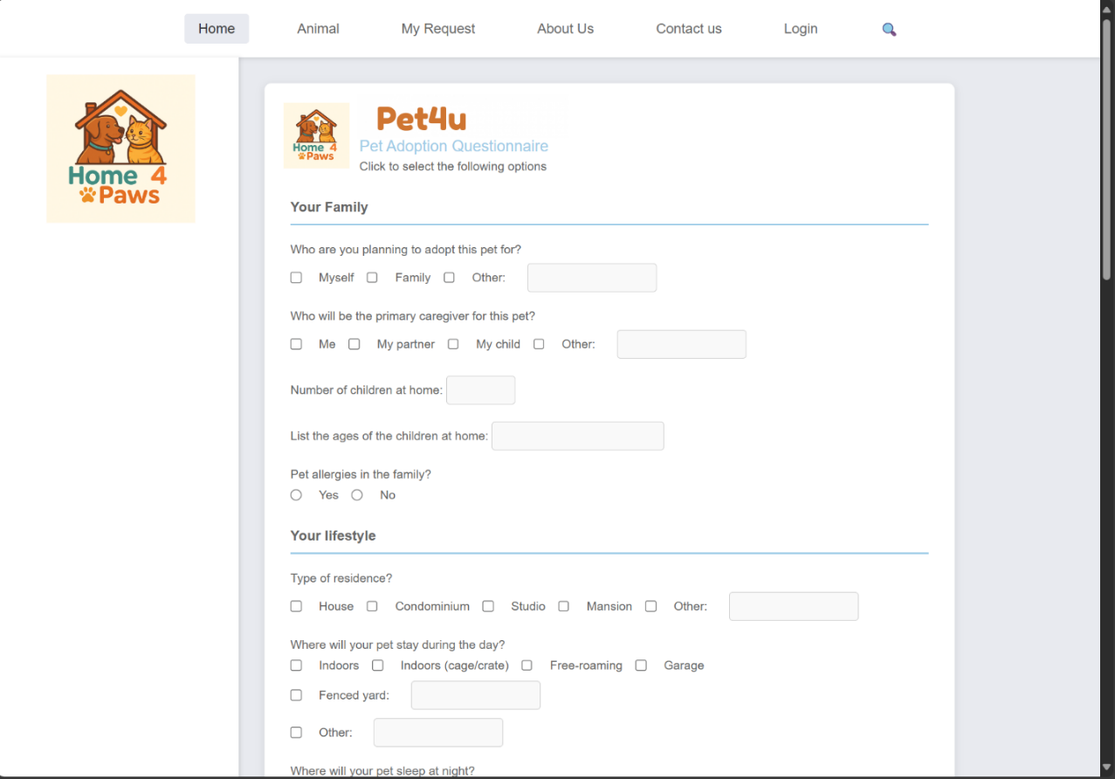

Figure 9: Contact Us

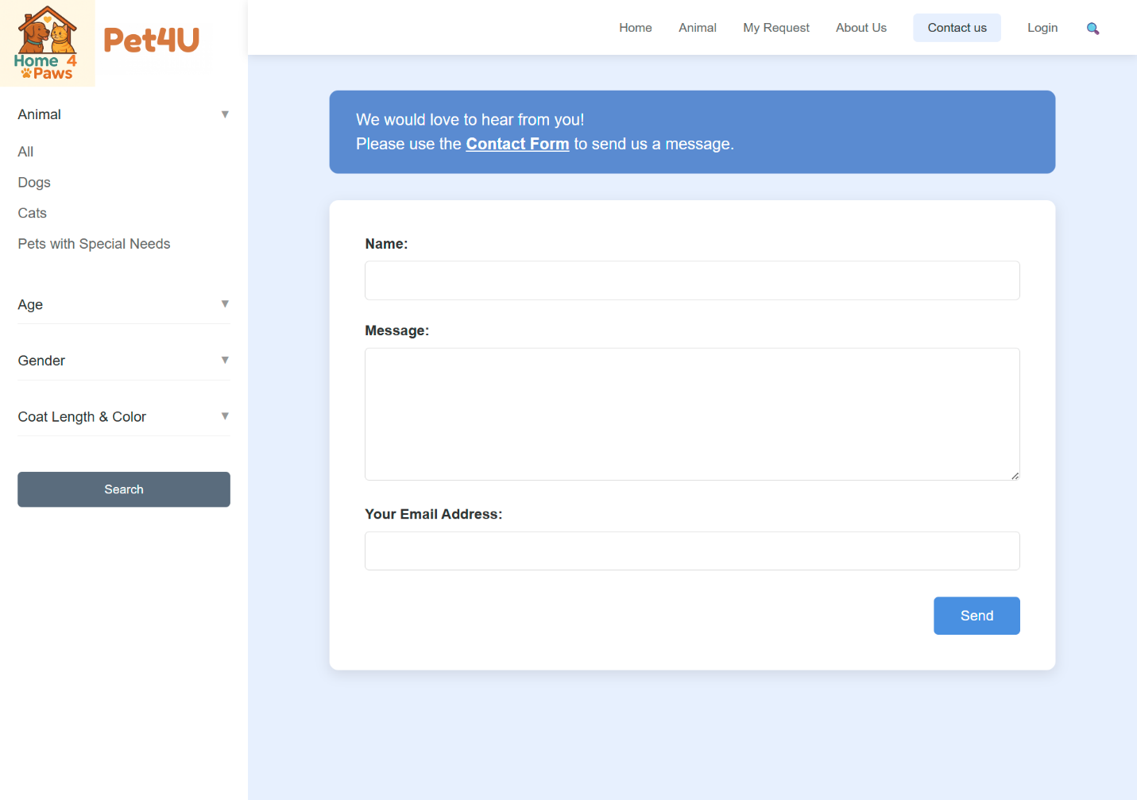

### **7.1.2** Output Interface

Figure 10: View Animals - All

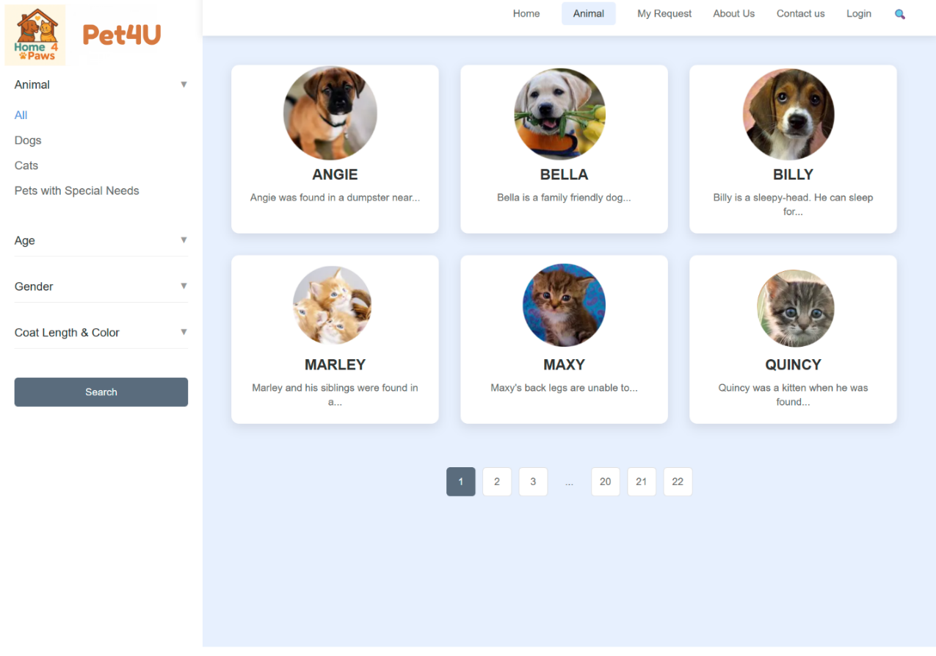

Figure 11: View Animals - Dogs

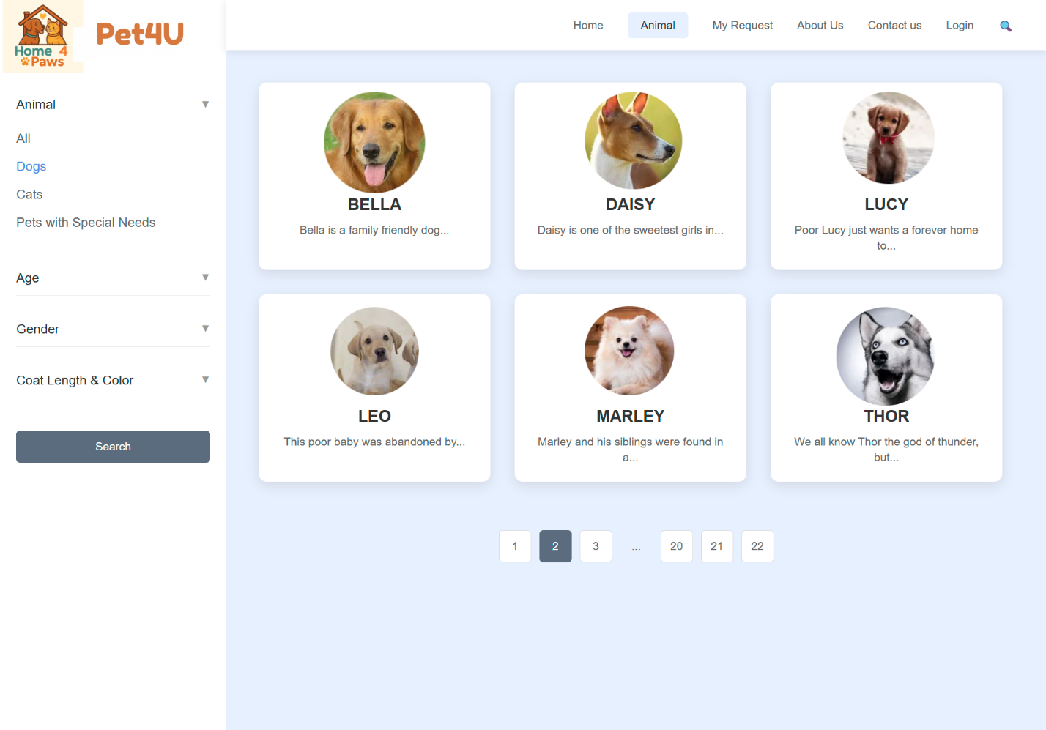

Figure 12: View Animals - Cats

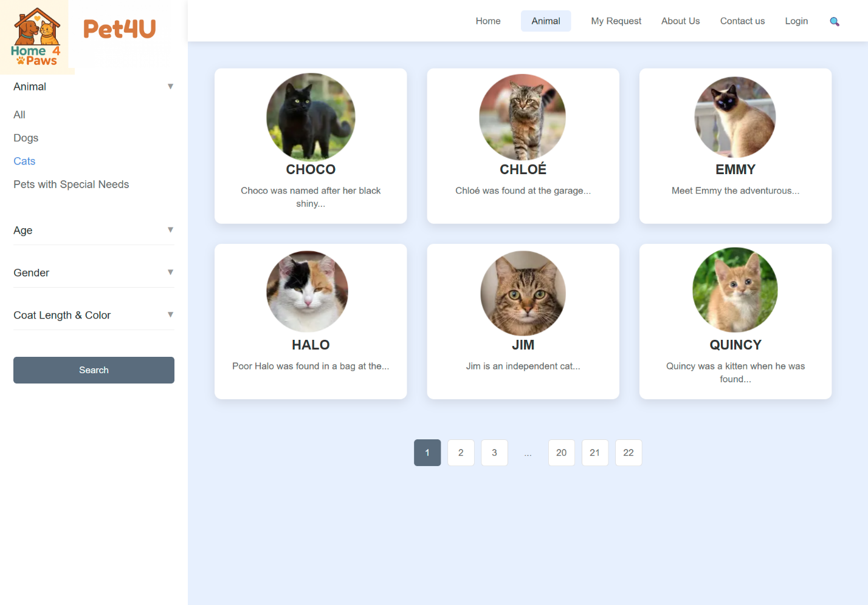

Figure 13: View Animals - Pets with Special Needs

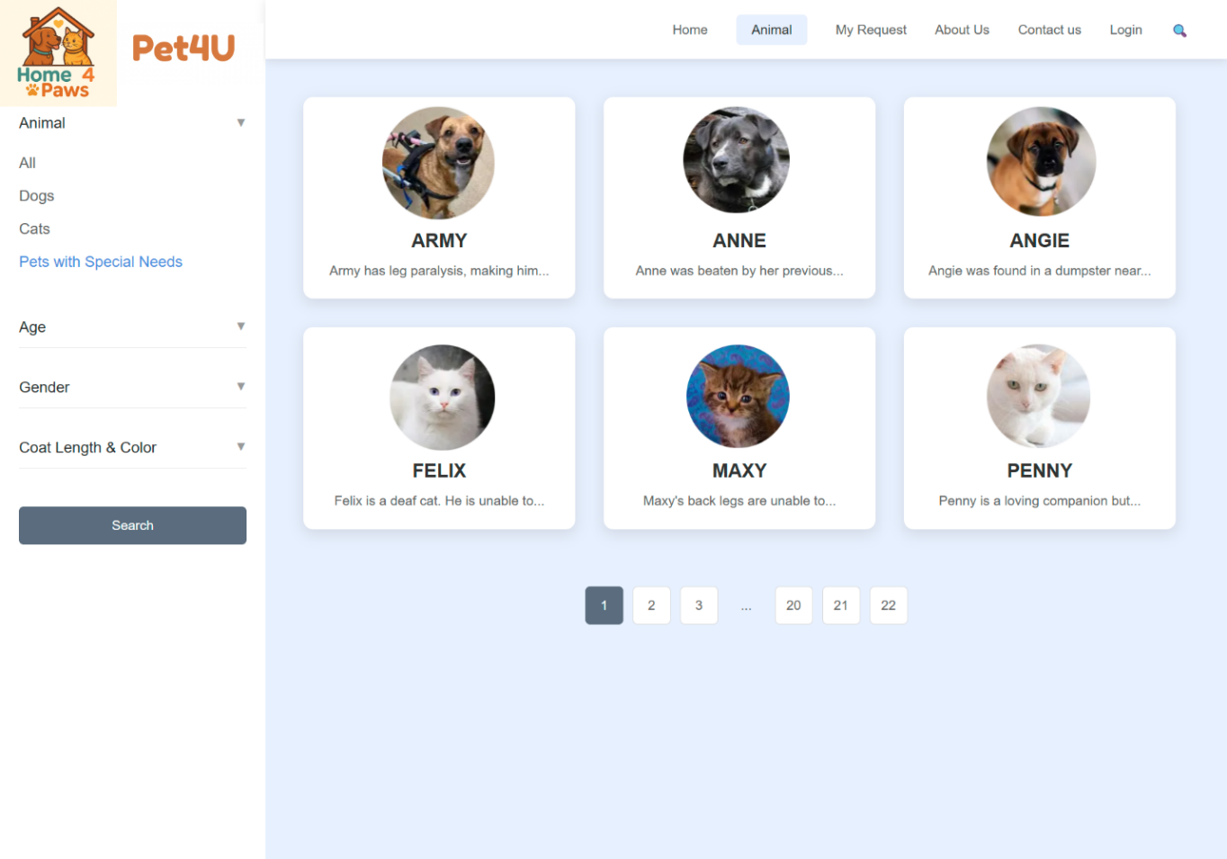

Figure 14: View Animals’ Profile

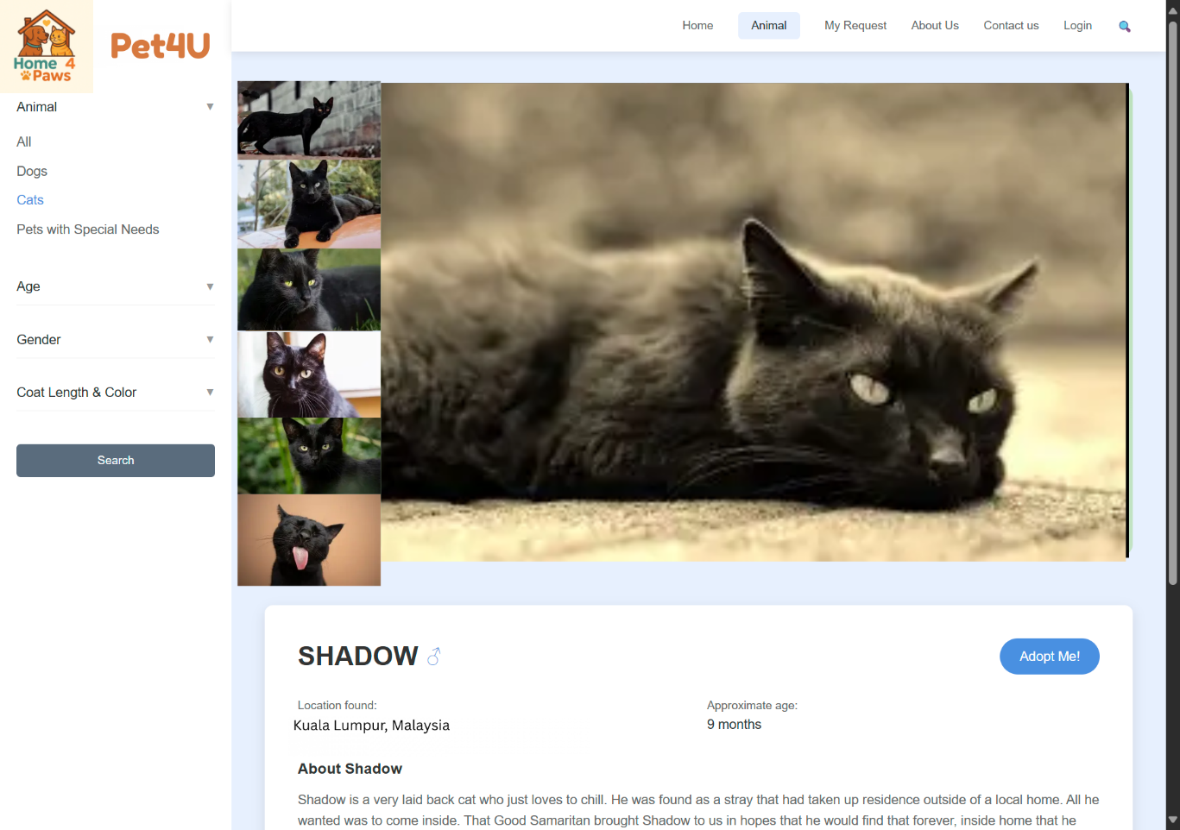

Figure 15: About Us

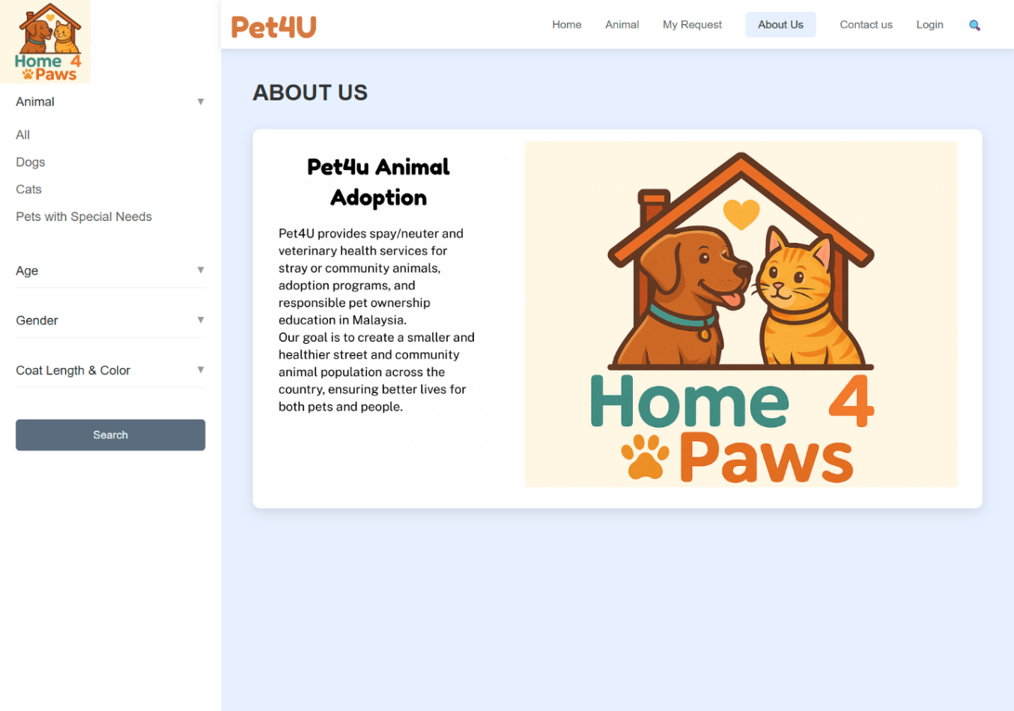

Figure 16: Contact Us

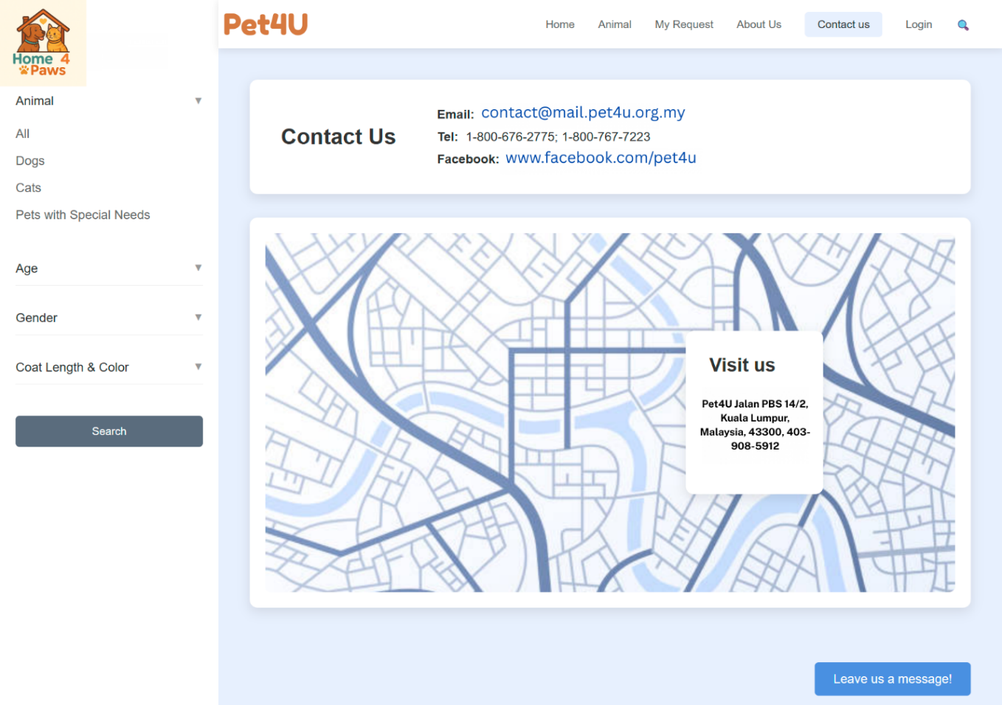

## **7.2** Administrator Interface

**7.2.1** Input Interface

Figure 17: Homepage - Manage Animals

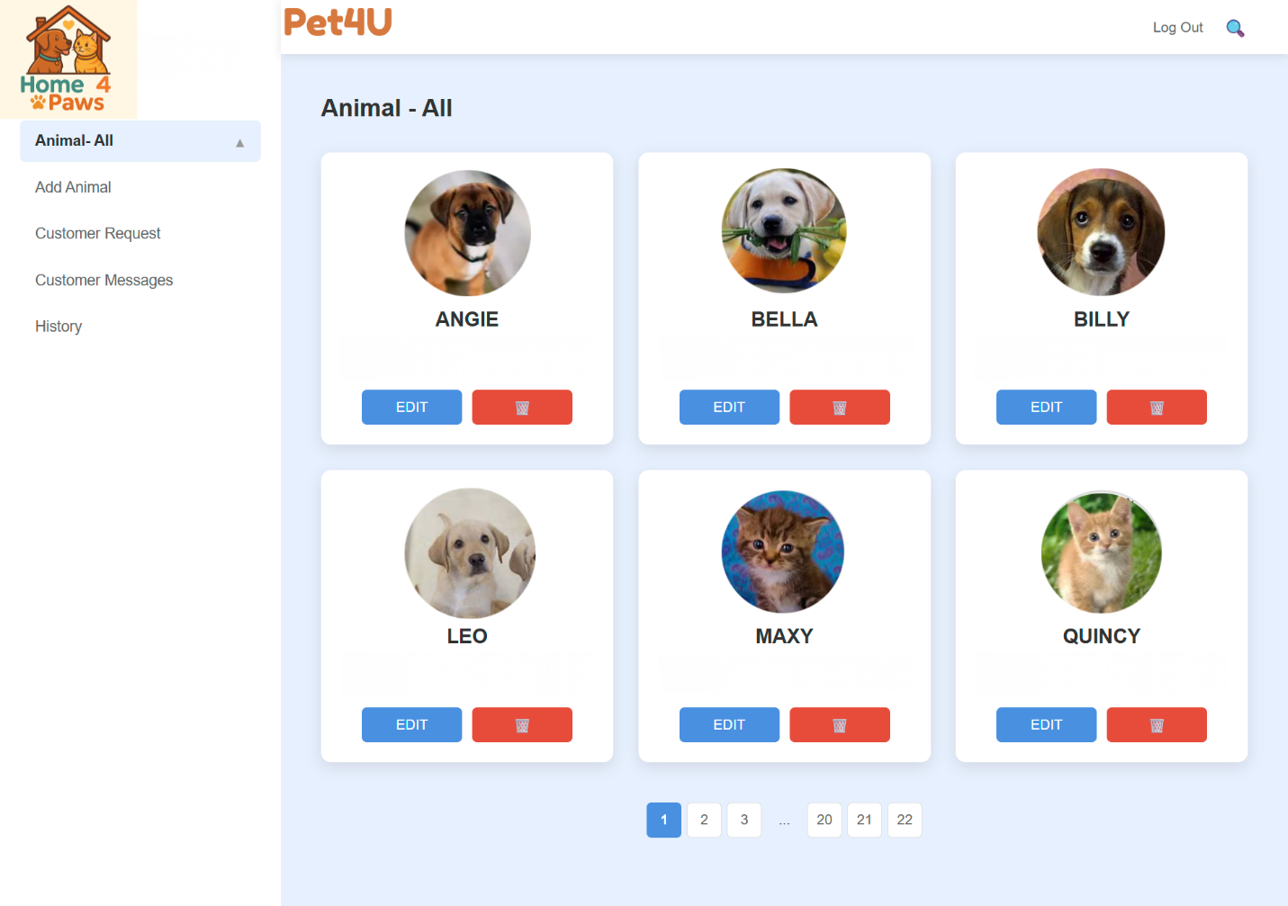

Figure 18: Edit Animals

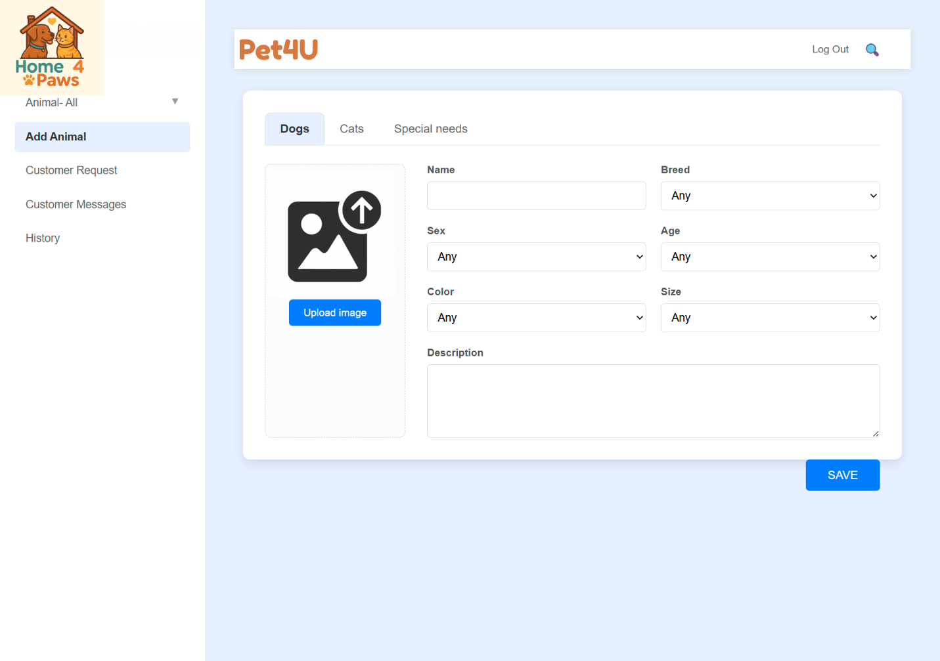

Figure 19: Add Animal

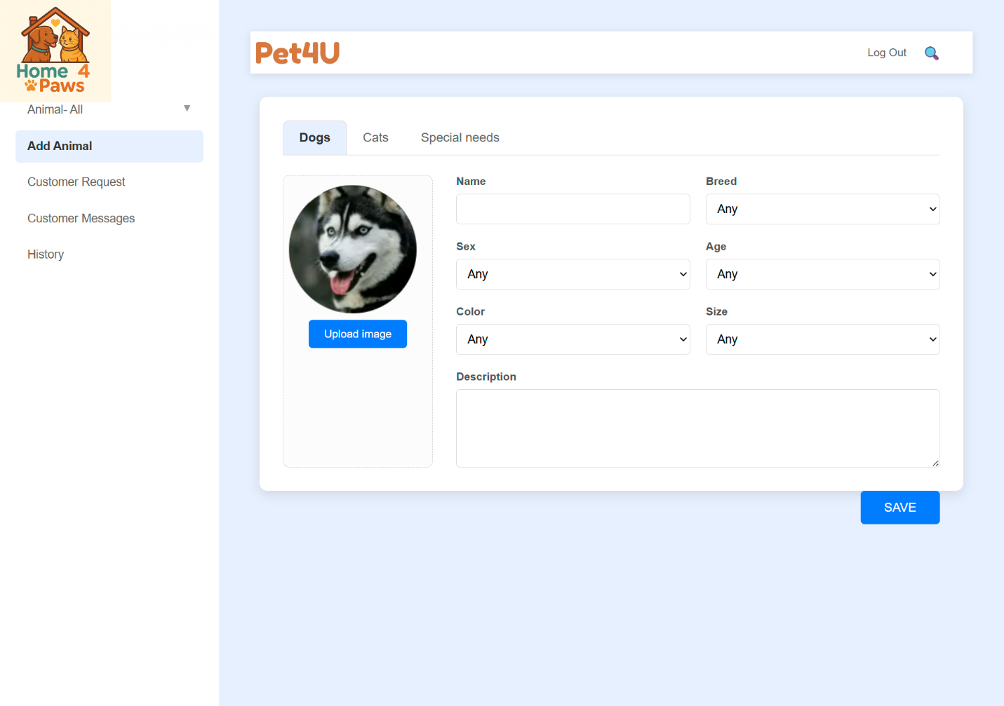

Figure 20: Adopter Requests

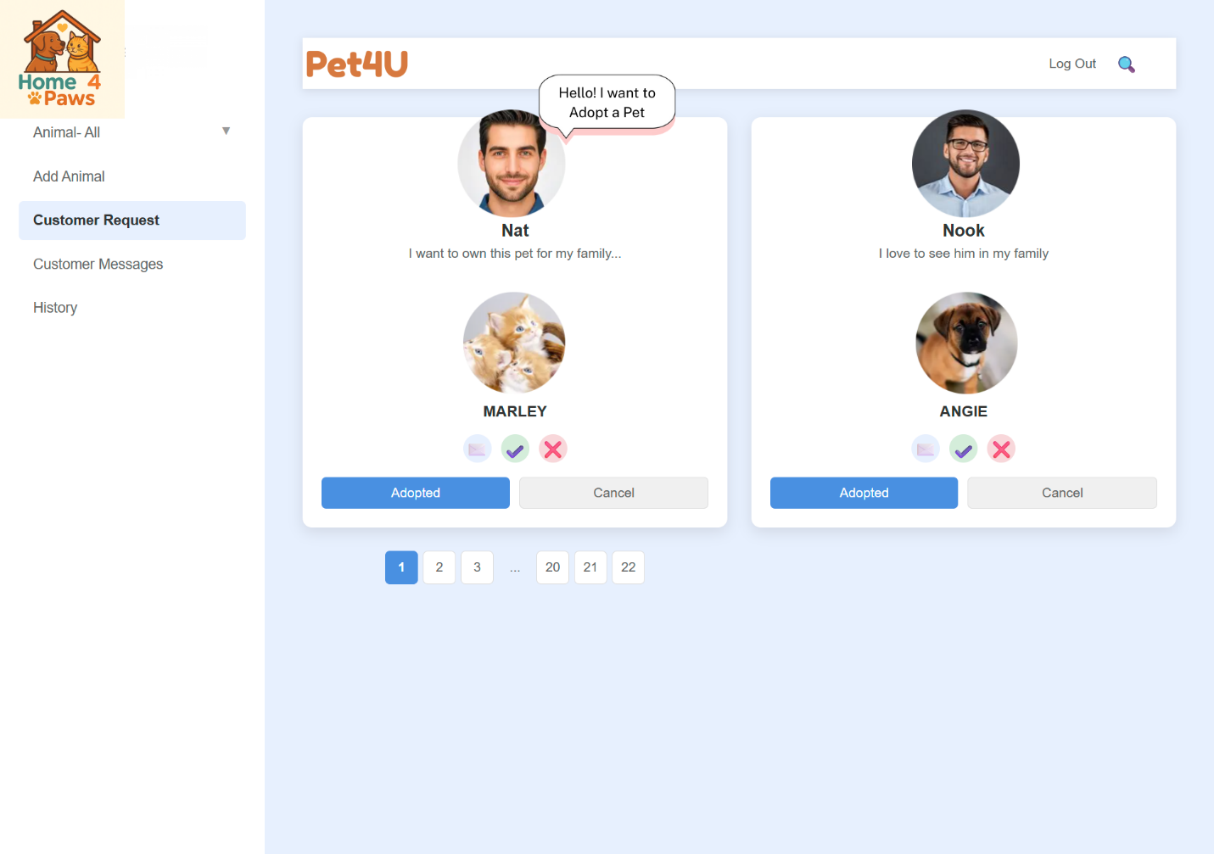

**7.2.2** Output Interface

Figure 21: View Adopters' Request

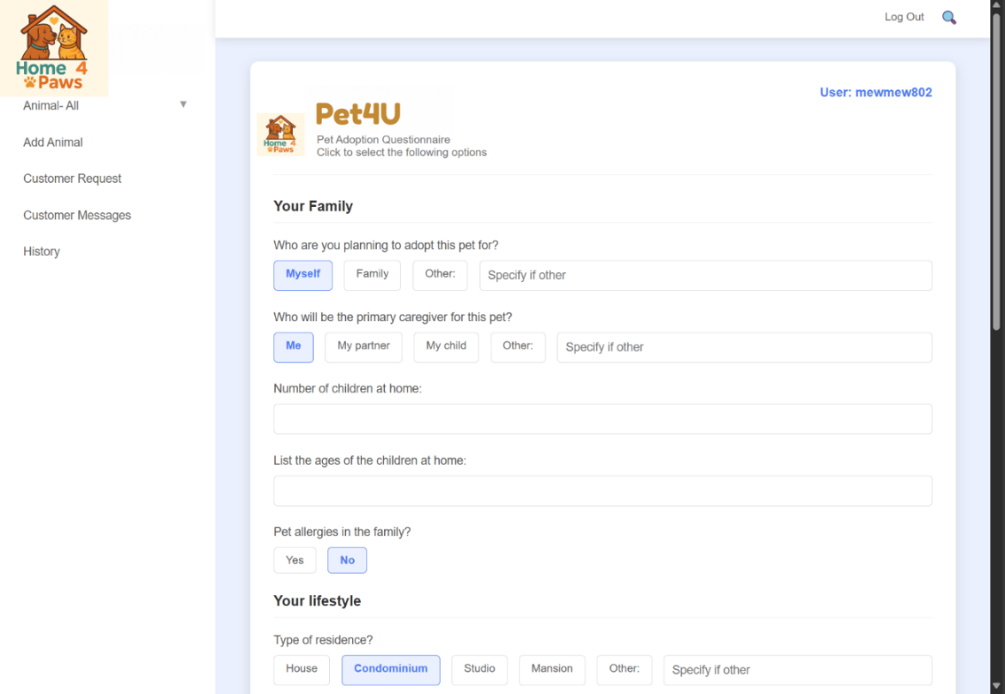

Figure 22: View Adopters' Messages

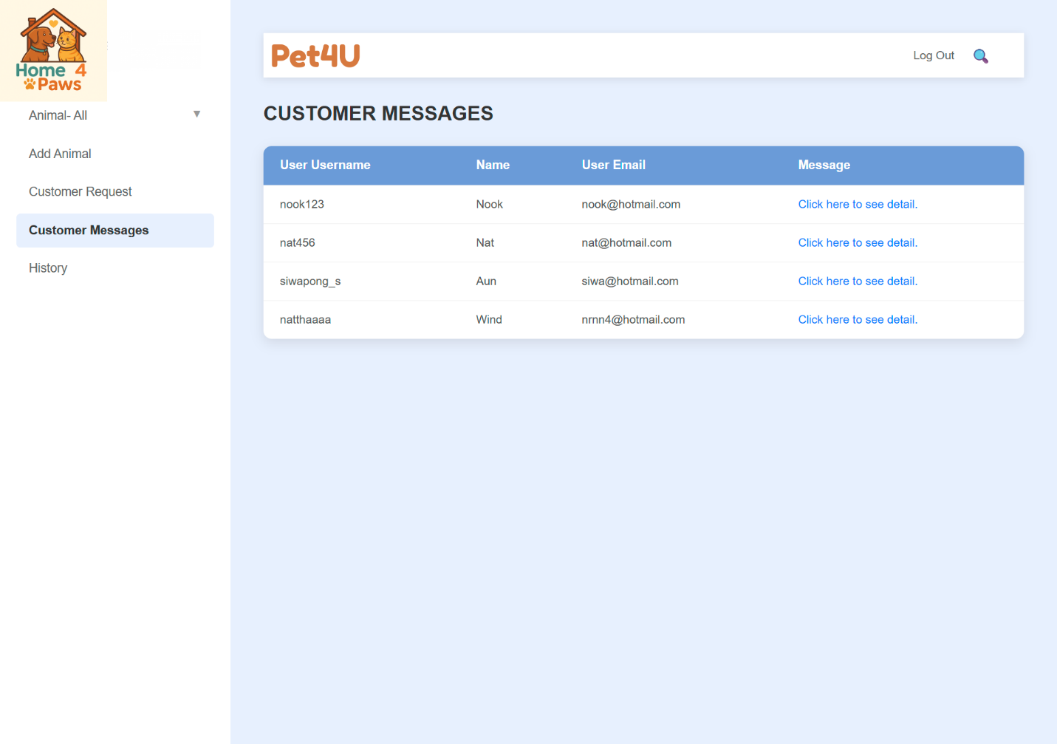

Figure 23: View Adoption History

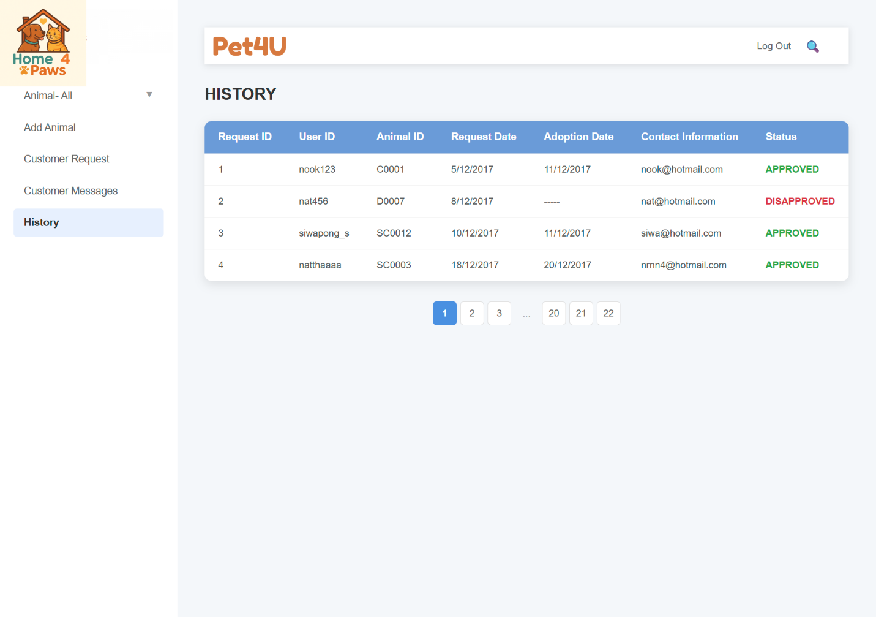

## **7.3** Shelter Staff Interface

**7.3.1** Input Interface

Figure 24: Task Management

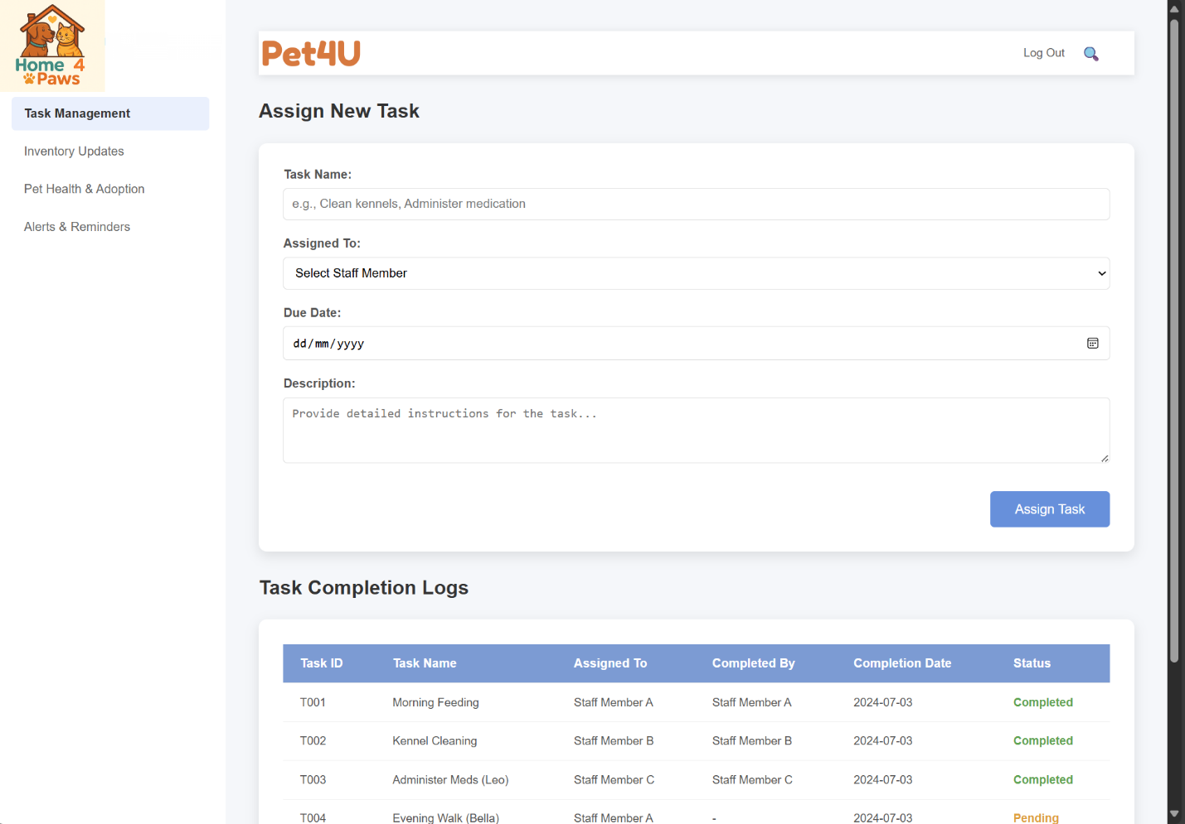

Figure 25: Inventory Updates

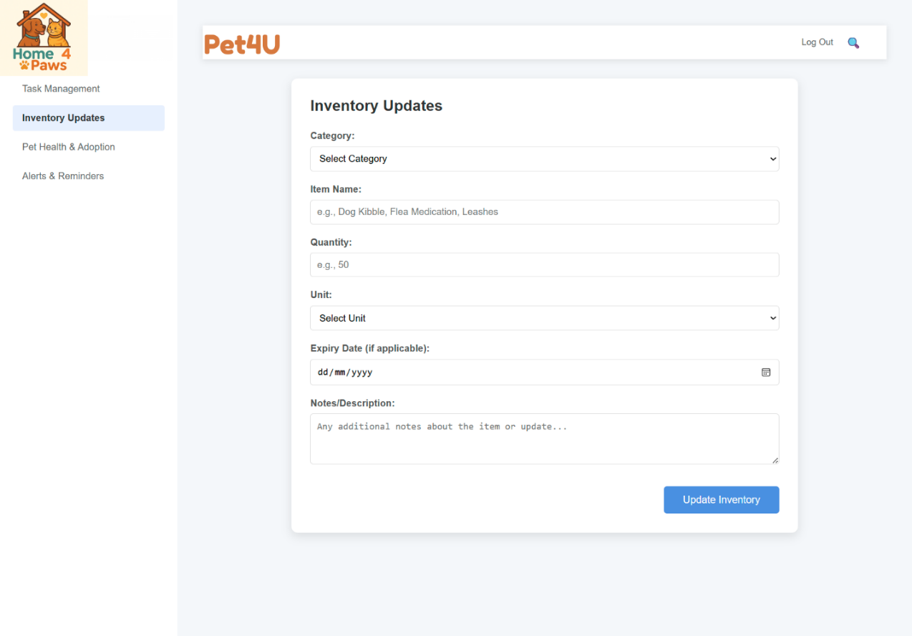

**7.4.2** Output Interface:

Figure 26: Pet Health & Adoption

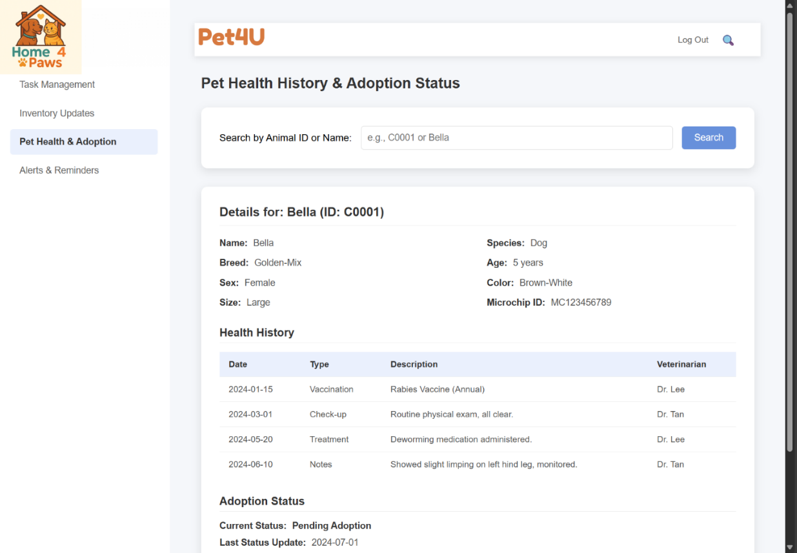

Figure 27: Alerts & Reminders

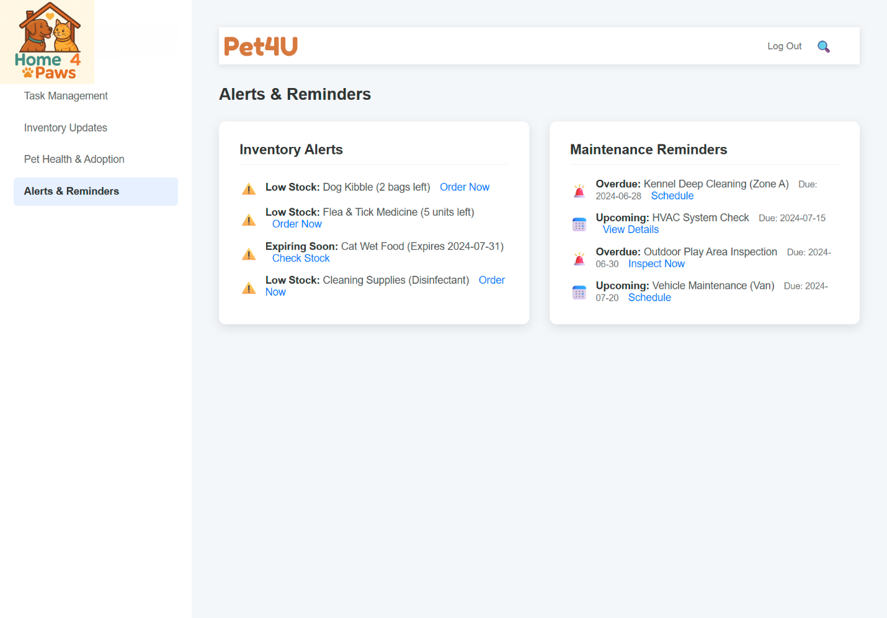

## **7.4** Donor Interface

### **7.4.1** Input Interface

Figure 28: Donation Details

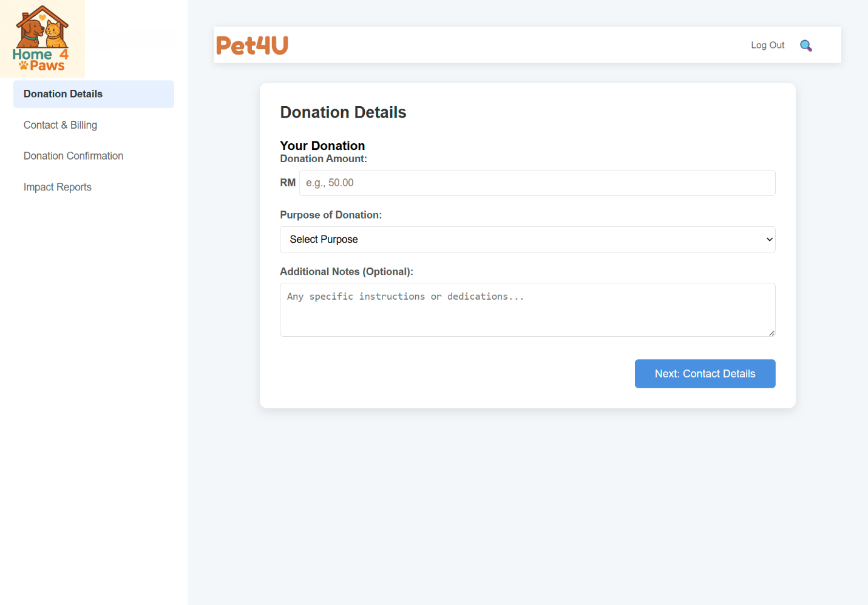

Figure 29: Contact & Billing

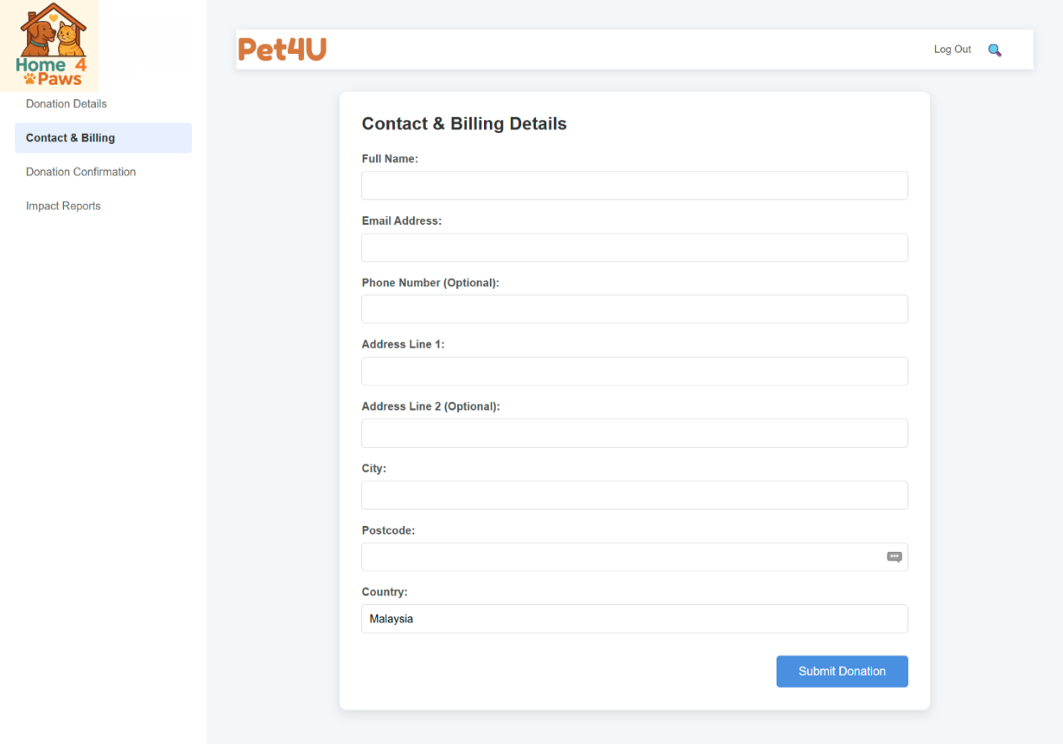

### **7.4.2** Output Interface

Figure 30: Donation Confirmation

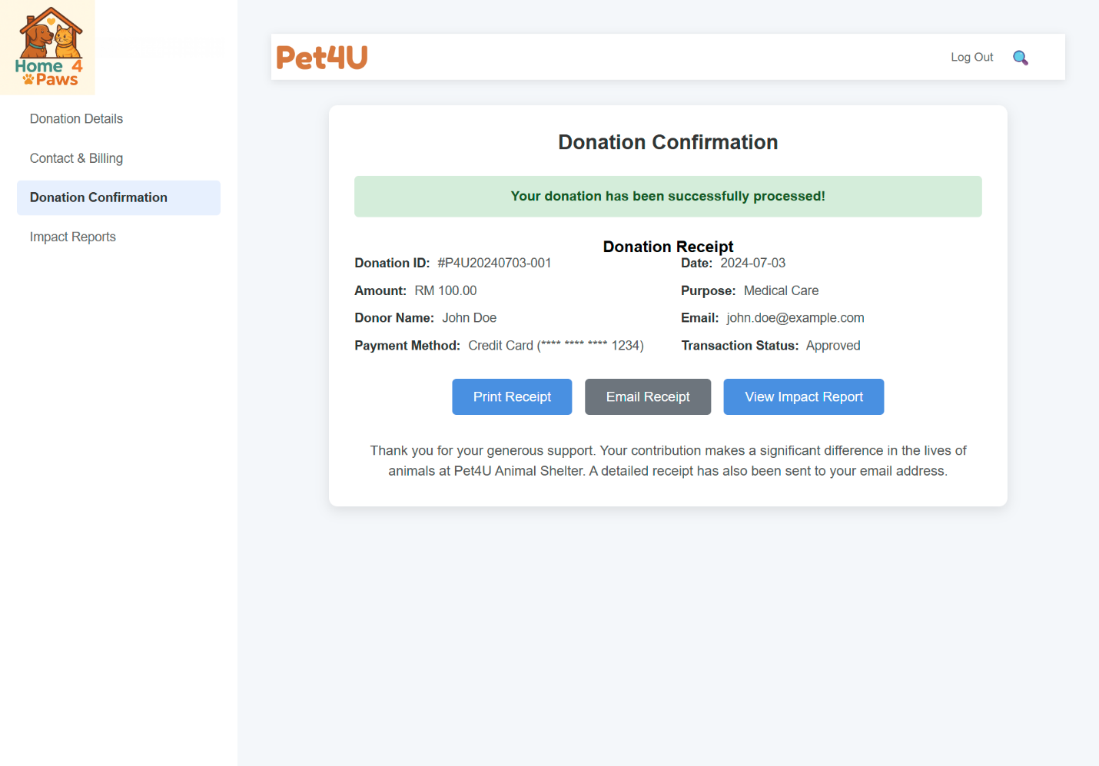

Figure 31: Impact Reports

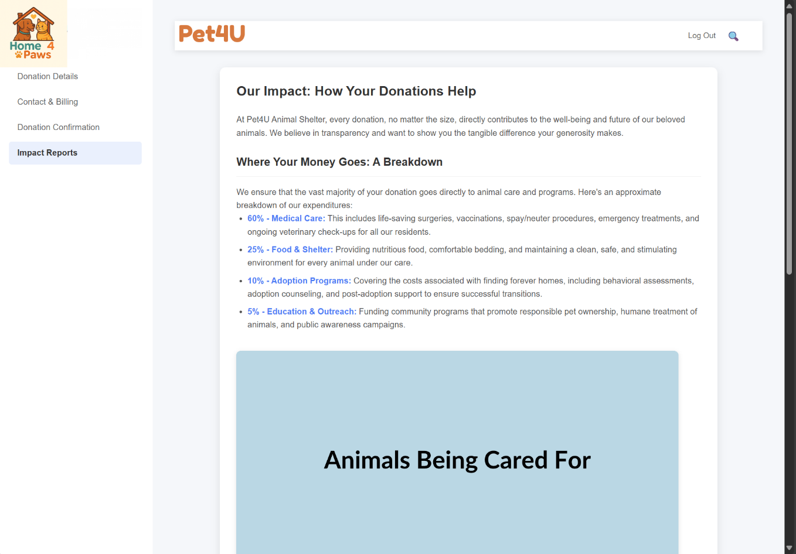

## **7.5** Volunteer Interface

### **7.5.1** Input Interface

Figure 32: Volunteer Profile

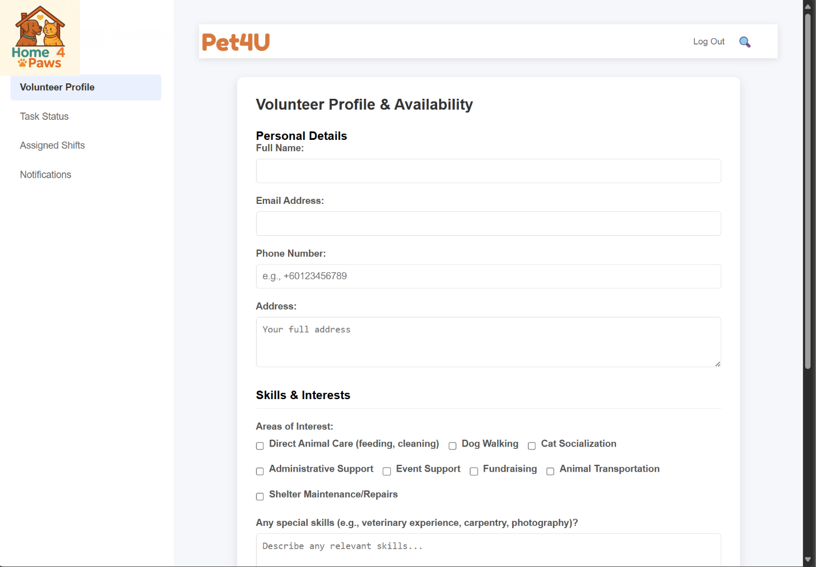

Figure 33: Task Status

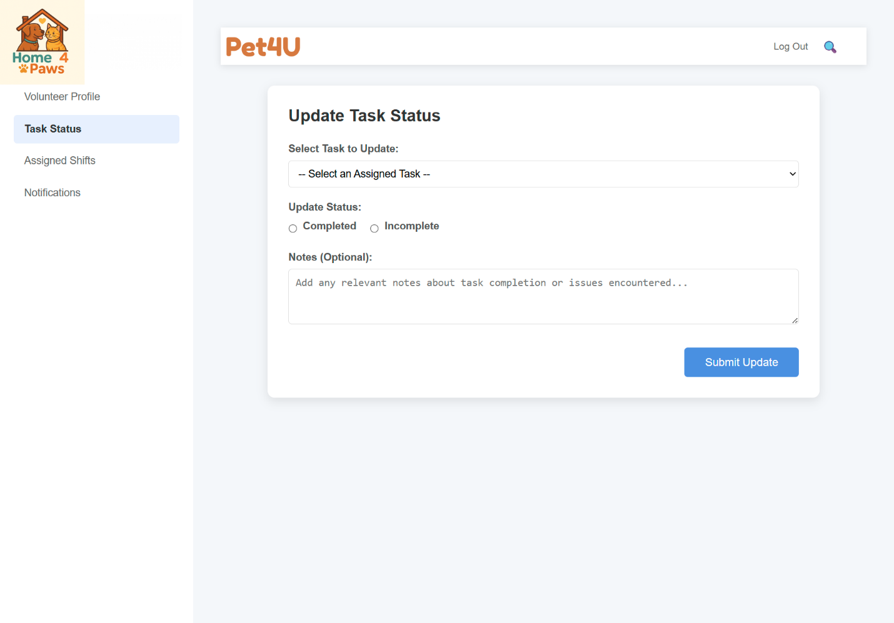

### **7.5.2** Output Interface

Figure 34: Assigned Shifts

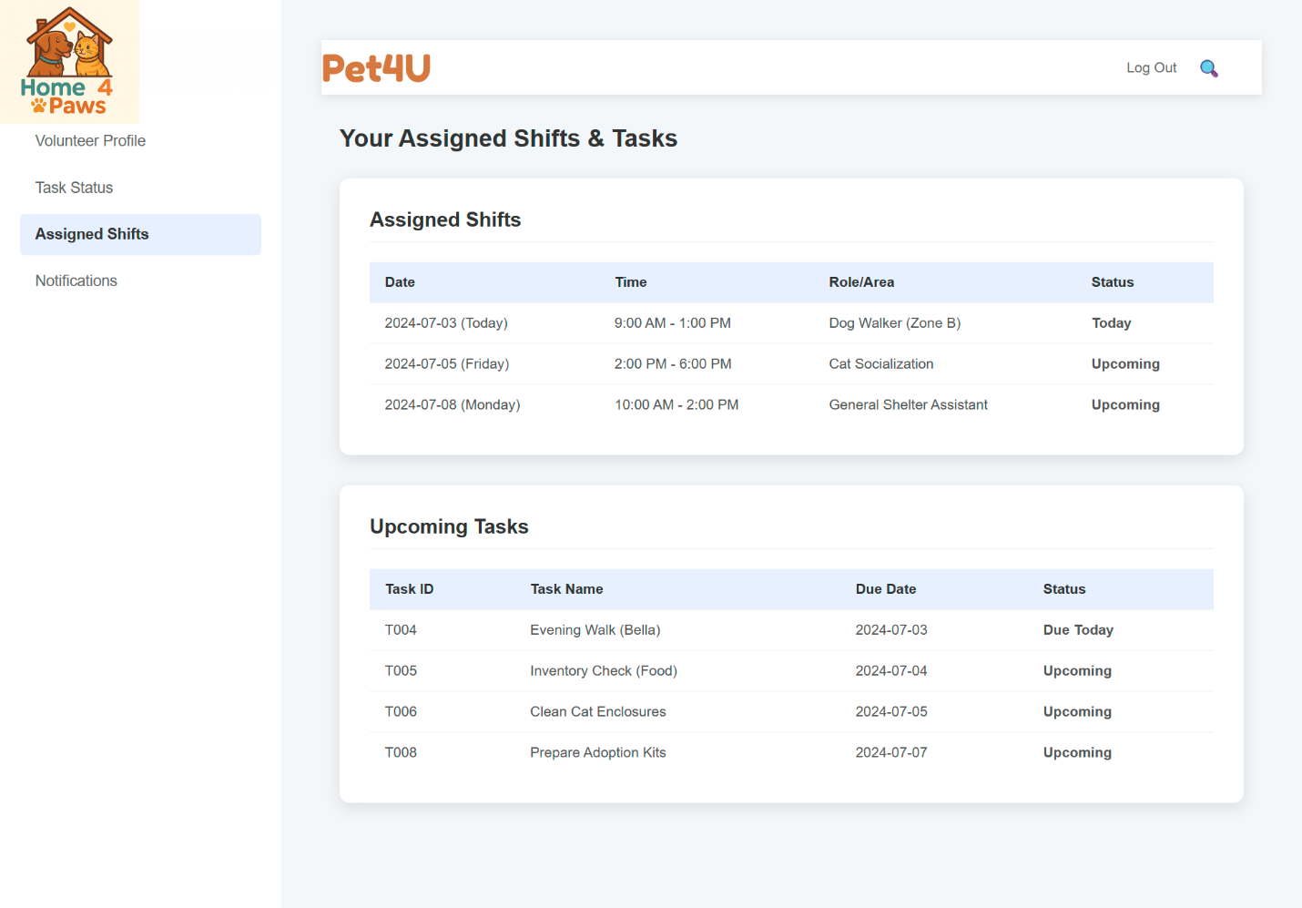

Figure 35: Notifications

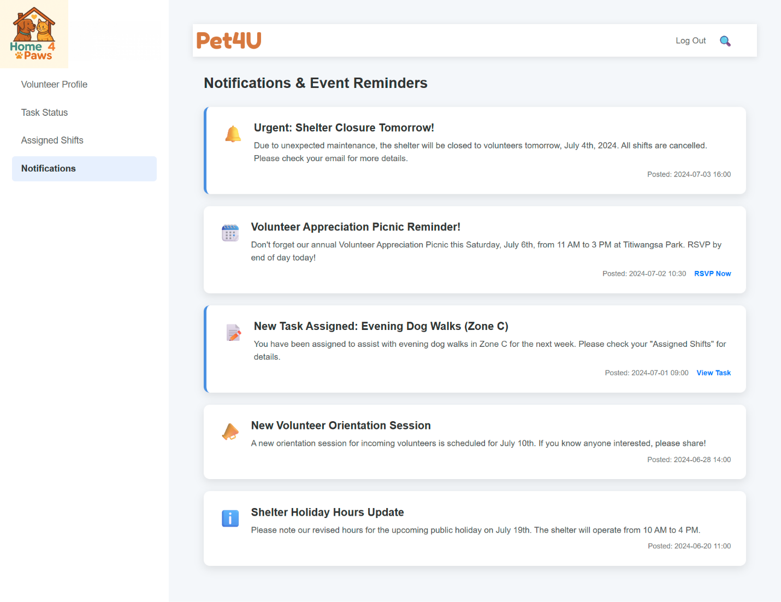

# CHAPTER 8: REQUIREMENT GATHERING

## **8.1**Ahmed Mirahusain Alvi - Document Review

**8.1.1** An Overview

For the development of the Pet Adoption Management System (PAMS), I used document review as one of my main techniques for gathering requirements and understanding how the Pet4U shelter operated. I analyzed a range of internal documents, including pet intake forms, volunteer sign-up sheets, adoption applications, vaccination logs, shift schedules, inventory lists, donor records, and previous reports. Reviewing these materials helped me understand how their current manual system functioned and what information they tracked. Since Pet4U relied heavily on offline paperwork and disconnected processes, document review gave me a structured, low-disruption way to explore their workflows and spot inefficiencies. It also allowed me to collect factual, unbiased data without immediately needing input from the shelter’s busy staff. Most importantly, this approach gave me a solid starting point to guide the transition from manual processes to a cloud-based system, ensuring that the future version of PAMS would reflect the shelter’s real operational needs.

**8.1.2** Advantages

Document review was especially helpful for the PAMS project because it allowed me to gather key insights without disrupting shelter operations. Since the Pet4U staff were often busy caring for animals, I was able to independently review adoption forms, health records, inventory logs, and donor lists to understand how things were being handled. These documents gave me clear, objective information about core processes like pet intake, volunteer scheduling, and donation tracking. Through this, I uncovered gaps—like the lack of connection between volunteer shifts and assigned pet tasks—and spotted inconsistencies in how data was recorded. This showed a need for standardization in the future system. I also compared official policies, such as adoption eligibility criteria, with how those were actually applied in practice. Document review helped me accurately map out the “as-is” state of operations, which laid the groundwork for designing streamlined, automated workflows that would better support both staff and animals through PAMS.

### **8.1.3** Limitations

While document review provided valuable structure, I also ran into several limitations. Many of the documents were outdated or didn’t reflect how the shelter actually operated day-to-day. For example, some forms listed vaccination requirements that, according to later interviews, were sometimes skipped when staff were overwhelmed—something that wouldn’t have been obvious from the paperwork alone. Some documents were also confusing due to handwritten notes or inconsistent field naming, which led to some early misinterpretations on my part. More importantly, the documents couldn’t capture the deeper, experience-based knowledge that staff relied on—like how they intuitively matched pets with adopters or adapted to last-minute changes in volunteer coverage. That kind of insight lives in people, not paper. Document review gave me a partial view, but not the full picture. To truly understand what the new system needed to support, I had to pair document review with direct conversations, observation, and real-time engagement with the people doing the work.

### **8.1.4** Conclusion

In the PAMS project, document review gave me a solid starting point to understand shelter operations and spot inefficiencies. It helped me identify key data points and sketch out initial workflows that matched existing processes. But it also made me realize how much it missed—like the informal practices, human judgment, and day-to-day flexibility that aren’t written down anywhere. That’s why I didn’t rely on it alone. I combined document analysis with interviews, shadowing, and walkthroughs to get a more complete picture. That approach helped me design a system that does more than digitize—it truly improves how Pet4U supports animals, staff, and adopters.

## **8.2** Sultan Abdulla Omar Takrori – Research

### **8.2.1** An Overview

Research, as a method of requirements gathering, involves collecting information from external sources such as competitor platforms, industry best practices, academic insights, and technological trends. For Pet4U—a non-profit animal shelter based in Kuala Lumpur that has been rescuing and rehoming dogs and cats since 1987—this approach is crucial in identifying solutions that can enhance its current adoption process. The shelter currently houses over 500 pets and dogs, but its reliance on traditional, manual operations has introduced inefficiencies. These include slow adoption processing, outdated pet records, limited outreach, and difficulty matching pets with adopters. These issues increase the time animals spend in shelters, limit the adoption success rate, and make it hard for both adopters and shelter administrators to manage and track pet information. Through research, CodeNova aims to understand how similar platforms have overcome these challenges and which of their features can be adapted effectively.

### **8.2.2** Advantages

A prime example of a digital platform that supports pet adoption is Adopets, a well-established system that provides a seamless experience for both shelters and adopters. By examining Adopets, several advantages have been identified that can benefit Pet4U. Firstly, Adopets allows for automation of the entire adoption process—from viewing pets to submitting applications and scheduling appointments—all from one centralized platform. This aligns well with Pet4U’s goal to eliminate paperwork and simplify adoption procedures. Secondly, the platform provides real-time availability of adoptable pets, which helps in reducing misinformation and ensures that prospective adopters are always seeing up-to-date listings. Thirdly, Adopets offers built-in screening tools that assess applicants before proceeding with adoption. This is crucial for ensuring responsible pet ownership and helps Pet4U make better decisions about who is qualified to adopt. Additionally, the system supports integration with veterinary services and microchip databases, which would help Pet4U track vaccinations, spaying/neutering status, and follow-up care efficiently. With mobile compatibility, the platform further extends accessibility, allowing users to engage with the adoption process on their own terms.

### **8.2.3** Limitations

While Adopets offers a wide range of useful features, not all of them are entirely beneficial or relevant to Pet4U’s specific needs and context. One significant concern is its pricing model. Many of Adopets’ advanced functionalities are subscription-based, which could strain Pet4U’s limited budget of RM 80,000. Investing in premium tools might divert resources from other crucial areas such as animal care and infrastructure. Additionally, Adopets was designed primarily for large-scale shelters in Western countries, meaning some of its workflows may not align well with the regulations, cultural expectations, or operational style of a Malaysian-based shelter like Pet4U. Another disadvantage is the limited customization options available in third-party platforms. Pet4U may require localized features—such as integration with Malaysian animal health regulations or local payment gateways—that are not easily adjustable within Adopets. Furthermore, depending heavily on an external platform can lead to a loss of control over data, including sensitive information about adopters and pet medical histories, posing potential privacy and security risks in the long term.

### **8.2.4** Conclusion

In summary, research as a technique has provided valuable insights into how Pet4U can improve its pet adoption process. By analyzing platforms like Adopets, Pet4U can adopt industry best practices such as real-time pet listings, digital applicant screening, and integrated health record systems. However, it is crucial to evaluate these features critically to avoid adopting functions that may not align with the shelter’s local context, budget limitations, or customization needs. Ultimately, a well-researched Pet Adoption Management System tailored to Pet4U’s specific requirements will not only enhance operational efficiency but also ensure more pets find safe and loving homes in a timely manner.

## **8.3** Mohammed Yousef Mohammed Mohammed – Sampling

### **8.3.1** An Overview

In developing Pet4U's Pet Adoption Management System, a sampling method was used to collect targeted input from stakeholders directly involved in day-to-day operations. A small, diverse group was selected, including four adopters, three shelter staff, two volunteers, and one administrative officer. This group represented the main types of users who interact with the system. Sampling allowed us to focus on participants who faced challenges with the current manual system, such as slow adoption processing, poor follow up, and inefficient communication. Each participant was asked a set of structured questions about their preferred features in the digital system. The collected data was then  analyzed to determine the prerequisites for automation, instant updates, and system accessibility. This helped prioritize system improvements that had the greatest impact on day-to-day operations, ensuring the system met practical, real-world needs. Sampling was chosen because of the time constraints and clear structure it provides for early requirements gathering.

### **8.3.2** Advantages

One of the major advantages of using the sampling method to collect requirements in a Pet Adoption Management System case study is efficiency. It allows valuable insights to be gathered from a smaller, more focused group without having to involve all stakeholders. By selecting participants directly involved in the processes such as adopters, shelter staff, volunteers, and administrators, we ensured that feedback was highly relevant and specific. Sampling also saved time and resources while still providing diverse perspectives from different user roles. The targeted data collected helped us identify the most pressing issues in the current system, such as delays, lack of access to medical records, and disorganized volunteer coordination. This made it easier to define system features such as automated pet tracking, central data storage, and communication tools. Additionally, sampling enabled us to build a system that more closely aligns with user expectations, ensuring higher satisfaction and ease of use once implemented. It is particularly useful during the early planning phase of system development.

### **8.3.3** Limitations

Although useful, the sampling method has some limitations when applied to Pet Adoption Management System requirements gathering. The main drawback is that the small group may not fully represent the wider user base. Important feedback from less active or less vocal stakeholders may be missed, resulting in a system that does not meet the needs of all users. For example, some adopters or volunteers not included in the sample may have unique challenges or preferences that remain unaddressed. There is also a risk of bias in participant selection  if the sampled group has similar opinions or experiences, the combined requirements may lack diversity. In addition, relying solely on sampling can lead to an incomplete understanding of rare but critical issues in shelter operations. This may affect the overall effectiveness and comprehensiveness of the final system design. To address these shortcomings, it is better to validate the sampling results through other methods, such as questionnaires or interviews.

### **8.3.4** ­­Conclusion

In conclusion, sampling has proven to be effective and time-efficient for collecting Adoption Management System requirements. By focusing on key stakeholders, adopters, staff, volunteers, and management we gained valuable insights into real world problems and user expectations. Although the representativeness of this method is limited, the observations collected provide a solid foundation for identifying the basic features of the system. To ensure wider relevance to the system, sampling results can be supported by complementary methods such as questionnaires or interviews. Overall, sampling helped ensure that the Pet Adoption Management System was practical, relevant, and user-focused from the start.

## **8.4** Abdallah Mohamed Mahmoud Mohamed Mahmoud – Observation

### **8.4.1** An Overview

One of the ways is observation and you simply look at what people are doing in the real setting. The process used in this project was the process of observation as I was studying the way the staff at Pet4U animal shelter performs its day-to-day tasks. I observed them doing the registration of pets, communication with adopters, cleaning the shelter and record keeping. This has enabled me to know their daily practice, the issues they encounter and what can be done to ease them. I also did not ask any questions or continue their work by interfering with them; I silently watched and learned how they usually perform. In doing so I could identify certain critical areas that include delays in the registration of pets, the problem of paper-based records and misunderstanding of tasks.

### **8.4.2** Advantages

Observation is quite effective since it can indicate how people actually perform their duties and not how they speak. There are cases of forgetting or different description of something happened being described when people are interviewed. However, when you can watch them, you could see the real issues. During my visit at Pet4U I realized that employees were repeating the tasks repeatedly or omitting on the steps to complete because of being much occupied. It was also easy to notice that some forms proved to be difficult to fill and employees needed to request help. All these minor issues compounded and slowed down the work. Since I was witnessing all this, I would understand very well the kind of modifications that require to be done to the system design. Through this approach, I got real, working experience of the work in the shelter.

### **8.4.3** Limitations

Although observation is beneficial, it has its disadvantages. To start with, it requires immense amount of time to see everything in the right manner. I was forced to be there at various times of the day to watch various activities. Also, knowing that they are under observation people can behave in other way and make an attempt to do better than normally which is also misleading. The next issue is use of observation- it does not give you what is inside the minds or the feeling. I could not always understand their motives but could read what they did. I would have to ask questions or conduct interviews in order to know that. And finally, it was not always simple to understand what I saw and describe it in a clear manner. It required concentration, at times, a second opinion to ensure that I was not getting anything wrong.

### **8.4.4** Conclusion

Finally, observation as a method to create requirements was a proper decision. It has assisted me to observe the actual life issues at the Pet4U shelter and provided me with helpful suggestions of what one can do to enhance their system. It was time-consuming and has some restrictions, but it helped me have a clearer idea of what the staff actually requires in their new system. It also assisted me in identifying those things which would have otherwise been ignored through other means such as interviews or surveys. Observation is most efficient when it is accompanied with other methods such as questionnaires or interviews. In this manner, you are able to get facts and the emotions of the users. In general, it is a non-complicated but an effective method of obtaining valuable information.

## **8.5** Sazid Ur Rahman Khan – Interview

### **8.5.1** An Overview

Interviewing was also used as one of the main requirements gathering techniques of Pet Adoption Management System (PAMS) in Pet4U. This was done through structured and semi-structured interviews of the key stakeholders, consisting of Adopters, Shelter Staff, Volunteers and the Admin. Both groups were useful in giving an insight on a current pain point, including manual entry of data, inability to monitor pet health history, and ineffective ways of communicating. Interviews gave analysts a chance to directly pose questions, clarify any confusion and obtain a context-relevant response regarding the way of work such as adoption screening and post-adoption follow-ups. The interviewing element involved both face to face and virtual interviewing session in which the prepared questions were administered based on the user role. There were concerns of system security and reporting tools raised by admins and the necessity of automation of pet care schedule raised by staff. Volunteers underlined the absence of coordination tools, and adopters interpreted the need to have their own recommendations and schemes facilitating the appointment process. The information gathered was the basis toward establishing the functional requirement of the system.

### **8.5.2** Advantages

Interviews aided in the determination of a number of benefits in the process of gathering requirements of the PAMS project. To begin with, they enabled the analysts to not only gain detailed and user-specific information, but also acquire an understanding of various viewpoints of the shelter-Admin operations, experiences of front-line staff, and expectations of adopters. This assisted in revealing requirements that were not spelled out, like the necessity to pin forecasts or to automatic follow-ups. Real-time refinement of ambiguous responses as well as more accurate organization of system modeling was also achieved because clarification of ambiguous responses and exploration of workflow interdependencies were made possible through interviews. The face-to-face format created rapport and a level of trust that made the stakeholders such as volunteers and adopters be free to voice inefficiencies of the system or frustrations with the manual processes. Interviews provided a platform where technical stakeholders such as admins could elaborate their expectations of security of the system, availability of data, and authority controls depending on the role. In general, the approach facilitated active engagement of the end-users in the process and increased the applicability of the intended digital solutions by putting them in tight relation with the needs of the users and the objectives of the organization.

### **8.5.3** Limitations

Although this method has its advantages, the interview method has also imposed some significant drawbacks in satisfying the PAMS requirement-gathering step. It was also cumbersome and needed a cautious scheduling coupled with little availability of personnel involved in shelters, volunteers, and adopters. This hindered the gathering of the detailed data, particularly where many candidates’ turnover occurred, as in the case of part-time volunteers. Also, data quality depended on the level of communication of the interviewees and their interest and ability to answer questions clearly, therefore, at times, follow-up interviews were necessary, because some of the respondents gave ambiguous responses. Interviewer bias also existed, it was possible to see that the preference in wording questions sometimes affected the responses and biased the results. Transcribing and interpretation of the interview involved additional time, and reconciling opposing opinions, as well as differences in priorities of the admins and needs of the adopters, was also difficult to carry out in the analysis. Finally, results could not be easily quantified because there were no standardized metrics in comparison to some methods such as questionnaires or the system logs. These shortcomings necessitated the use of additional techniques of validating as well as cross-checking the data that had been collected during the interview.

### **8.5.4** Conclusion

To sum up, interviews turned out a rather resource-expensive but powerful method of collecting key system requirements to PAMS. They provided tail-made information about operational lapses and enabled the team to learn the true face of user expectations particularly by the users who adopt, the shelter personnel, the volunteers, and the administrators. Though lengthy and on a few occasions, even unpredictable, the interviews played an invaluable role to developing a user-centered system as it shed light on the inefficiencies in workflow as well as requirements of features that would otherwise go undiscovered. In conjunction with other tools such as questionnaires and observation, interviews were used to make sure that the end product in terms of the system design was based on the reality on the ground with respect to how shelter works and what people expect of it.

## **8.6** Mahrus Shamsul Ahsan – Questionnaire

### **8.6.1** An Overview

A questionnaire is a research tool in the form of a series of questions that are used to gather information from respondents. A questionnaire can be paper or computer-based and can be utilized in surveys, interviews, and system development projects to gather consistent, measurable, and qualitative data. Questionnaires are crucial for understanding the needs, behaviors, and preferences of target users including staff, adopters, and the public.

Questionnaires are meant to collect the necessary information that aids in the development and enhancement of the system. They facilitate gathering user requirements by ascertaining what the users require of the system. The second key benefit of questionnaires is that they help to determine the pain points, reveal the inefficiencies or issues of the current manual processes. Also, they are employed in order to measure user satisfaction, giving an idea of how effective the current services are in satisfying the user's expectations. The feedback obtained can be used to inform the design decisions of the system, and thus the development will be informed by the actual needs and preferences of the users. Finally, questionnaires are useful to maintain stakeholder engagement, as it will involve adopters, staff, and the population in the research process. Therefore, creating trust and increasing the relevance and effectiveness of the system.

### **8.6.2** Advantages

There are some important benefits of questionnaires in research and system development. Among these advantages, there is standardized data collection because all respondents are asked the same questions, which means that the data is uniform and comparable. They are also cost effective and scalable, and able to reach large audiences within a short time and at a low cost. Also, questionnaires give measurable information, which can be mathematically analyzed to facilitate decision-making based on data. Their anonymity has been known to elicit honest answers as the respondents are less afraid to give their real opinion. Moreover, they facilitate user-centered design approach as they allow system developers to gain a better insight into real needs and preferences of users.

### **8.6.3** Limitations

Questionnaires however have several drawbacks as well. They may result in lower responses particularly when the survey is very long or when the respondents are not interested. It also lacks flexibility, since the respondents can only respond to what they are asked, missing out on valuable or deeper information. Improperly phrased or unclear questions may lead to misunderstanding, which will give inaccurate information. Also, there is a tendency of low response rates especially in voluntary surveys where there is no motivation. Lastly, there can be bias in responses where the participants will give socially acceptable responses rather than the truthful ones.

**8.6.4** Questionnaire Data

Figure 36 shows a pie chart statistic regarding challenges faced during the adoption process



Figure 37 shows a pie chart statistic of clarity of pet information

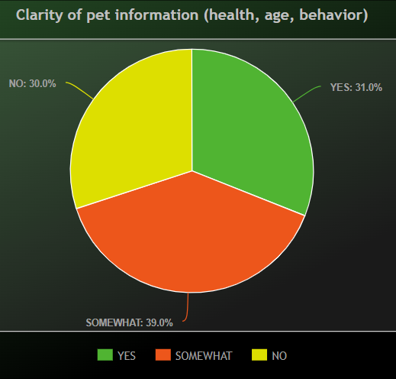

Figure 38 shows a pie chart regarding preference of adopting an online adoption platform by adopters

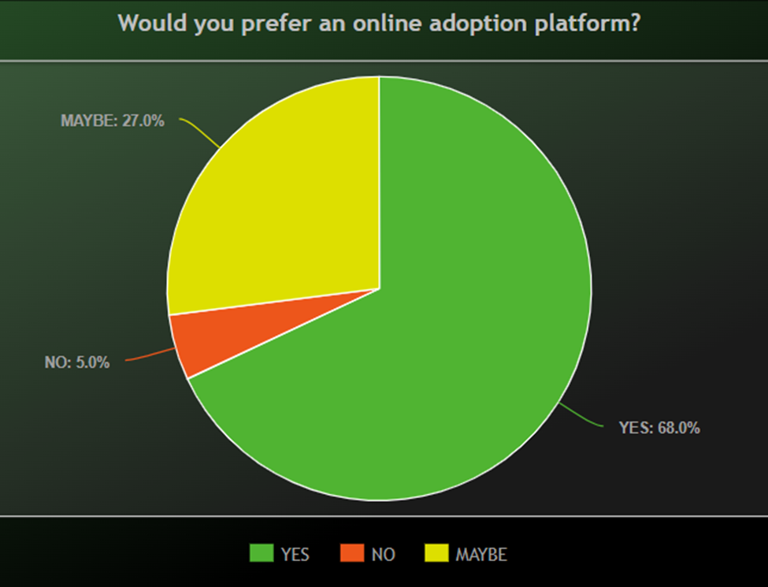

Figure 39 shows a pie chart regarding useful features in an Online System

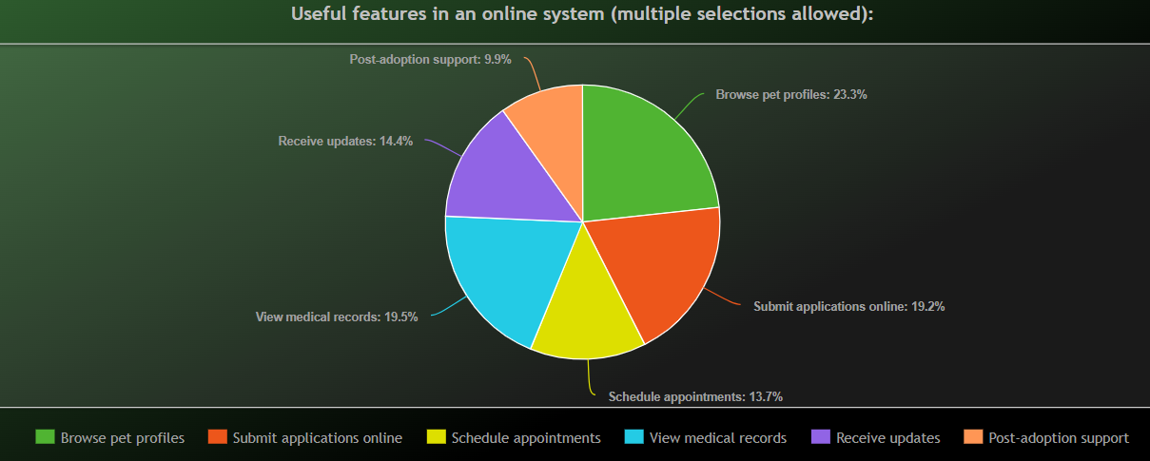

Figure 40 shows a pie chart statistic pertaining to a question

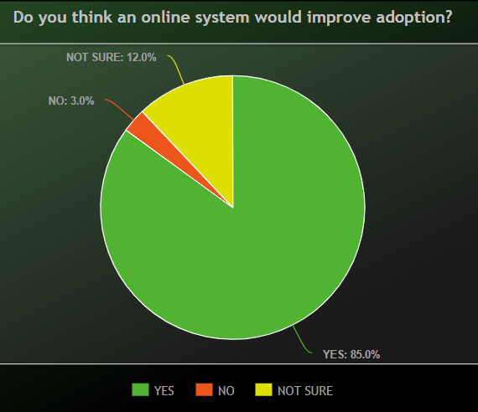

**Section A: General Information**

1. What is your role in relation to Pet4U?
2. Have you adopted a pet from Pet4U before?

**Section B: Experience with the Current Adoption Process**

1. How would you rate the current pet adoption process at Pet4U?
2. What challenges did you face during the adoption process?
3. Was the information about pets (e.g., medical history, temperament) clear and helpful?

**Section C: Interest in a Digital Adoption System**

1. Would you prefer using an online platform to adopt a pet?
2. Which features would you find useful in a Pet Adoption Management System?

**Section D: Feedback and Suggestions**

1. Do you think an online system would improve the pet adoption process at Pet4U?

# CHAPTER 9: DESIGN

## **9.1** Ahmed Mirahusain Alvi

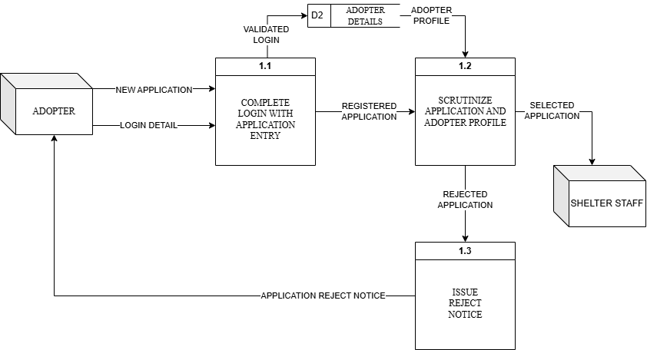

## **9.2** Sultan Abdulla Omar Takrori

Figure 41 shows Apply Payment Process DFD Level 1 Overview

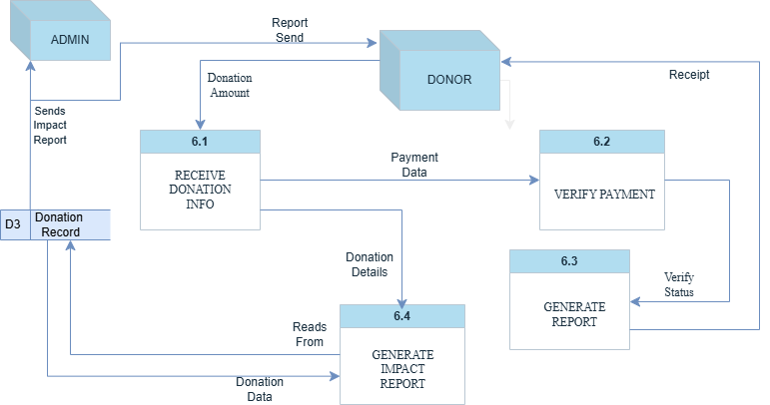

**DATA DICTIONARY**

PROCESS TABLE

|  |  |  |  |
| --- | --- | --- | --- |
| **Name** | **Description** | **Input Data Flow** | **Output Data Flow** |
| Receive Donation Info (6.1) | Gets the donation amount from the donor and sends payment info for checking. | Donation Amount | Payment Data ,  Donation Data |
| Verify Payment (6.2) | Checks if the payment made by the donor is successful. | Payment Data | Verify Status |
| Generate Receipt (6.3) | Creates and sends a receipt to the donor if the payment is successful. | Verify Status | Receipt |
| Generate Impact Report (6.4) | Makes a report to show how the donation was used. | Donation Details | Report Send |

EXTERNAL ENTITY TABLE

|  |  |  |  |
| --- | --- | --- | --- |
| **Name** | **Description** | **Input Data Flow** | **Output Data Flow** |
| Donor | The person who gives the donation and receives the receipt and report. | Donation Amount | Receipt, Report Send |
| Admin | The person who receives the donation impact report | Report Send | *NULL* |

**Data Flow Table (with Data Structure)**

|  |  |  |  |  |
| --- | --- | --- | --- | --- |
| **Name** | **Description** | **Origin / Source** | **Destination** | **Data Structure** |
| Donation Amount | The amount and info sent by the donor. | Donor | 6.1 Receive Donation Info | Doner ID +  Amount +  Timestamp |
| Payment Data | Payment details to be verified. | 6.1 Receive Donation Info | 6.2 Verify Payment | Amount +  PaymentMethod +  Transaction ID |
| Verify Status | Result of payment verification. | 6.2 Verify Payment | 6.3 Generate Receipt | Status + [Success/Fail] + Payment + Reference |
| Receipt | Confirmation sent to donor after successful payment. | 6.3 Generate Receipt | Donor | Receipt ID + Amount +  Date |
| Donation Data | Info saved into the donation record database. | 6.1 Receive Donation Info | D3 Donation Record | Doner ID + Amount +  Timestamp + Payment Info |
| Donation Details | Data pulled from the donation record for report generation. | D3 Donation Record | 6.4 Generate Impact Report | Doner ID +  Donation + Summary +  Timestamp |
| Report Send | Final impact report sent to donor. | D3 Donation Record | Donor | Report ID + Summary +  Metrics +  Usage Details |
| Sends Impact Report | Final impact report sent to Admin. | D3 Donation Record | Admin | Report ID +  Summary +  Metrics +  Usage Details |

**Data Store Table (with Data Structure)**

|  |  |  |  |  |
| --- | --- | --- | --- | --- |
| **Data Store Name** | **Description** | **Input Source** | **Used By / Output To** | **Data Structure** |
| D3 Donation Record | Stores all donation info for reports. | 6.4 Receive Donation Details | D3 Donation Record | Doner ID + Amount + Time + Payment + Receipt Info |

## **9.3** Mohammed Yousef Mohammed Mohammed

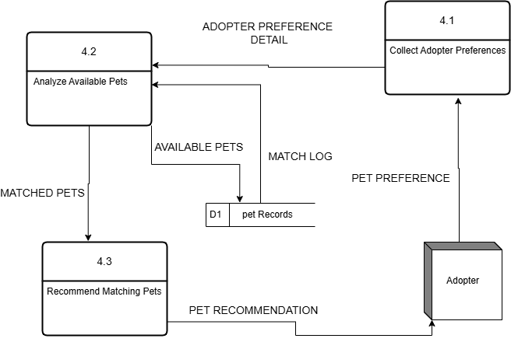

**DATA DICTIONARY**

PROCESS TABLE

|  |  |  |  |
| --- | --- | --- | --- |
| **Name** | **Description** | **Input Data Flow** | **Output Data Flow** |
| 4.1 Collect Adopter Preferences | Captures adopter's pet preference data via forms or digital inputs | Pet Preference | Adopter Preference Detail |
| 4.2 Analyze Available Pets | Compares adopter preference with available pets in the system | Adopter Preference Detail, Available Pets | Matched Pets, Match Log |
| 4.3 Recommend Matching Pets | Sends best-matching pets to the adopter for review | Matched Pets | Pet Recommendation |

ENTITY TABLE

|  |  |  |  |
| --- | --- | --- | --- |
| **Name** | **Description** | **Input Data Flow** | **Output Data Flow** |
| Adopter | A person interested in adopting a pet; interacts with system | Pet Recommendation | Pet Preference |

DATA FLOW TABLE

|  |  |  |  |  |
| --- | --- | --- | --- | --- |
| **Name** | **Description** | **Origin / Source** | **Destination** | **Data Structure** |
| Pet Preference | Data provided by the adopter regarding pet characteristics | Adopter | 4.1 Collect Adopter Preferences | Pet type +  age +  size + (temperament) |
| Adopter Preference Detail | Structured adopter requirements | 4.1 Collect Adopter Preferences | 4.2 Analyze Available Pets | Type +  Size +  Age + (Preferred Breed)  + (Color) |
| Available Pets | Pet details from the system database | D1 Pet Records | 4.2 Analyze Available Pets | Pet ID +  type +  status +  (health info) |
| Matched Pets | List of pets filtered based on preference | 4.2 Analyze Available Pets | 4.3 Recommend Matching Pets | Pet ID +  match score + basic profile |
| Pet Recommendation | Final suggested pets sent to adopter | 4.3 Recommend Matching Pets | Adopter | {List of pet}+ names + photos +  ID  (Brief Description) |
| Match Log | Stores result of the pet matching process | 4.2 Analyze Available Pets | D1 Pet Records | Match ID+ adopter ID + {pet list } |

DATA STORE

|  |  |  |  |  |
| --- | --- | --- | --- | --- |
| **Name** | **Description** | **Input Data Flow** | **Output Data Flow** | **Data Structure** |
| D1 Pet Records | Keeps pet information and logs of pet matching | Match Log | Available Pets | Pet ID +  name +  status + health+  {match history} |

## **9.4** Abdallah Mohamed Mahmoud Mohamed Mahmoud

Figure 42 shows DFD Level 1 Overview for Process 1: Process Pet Information

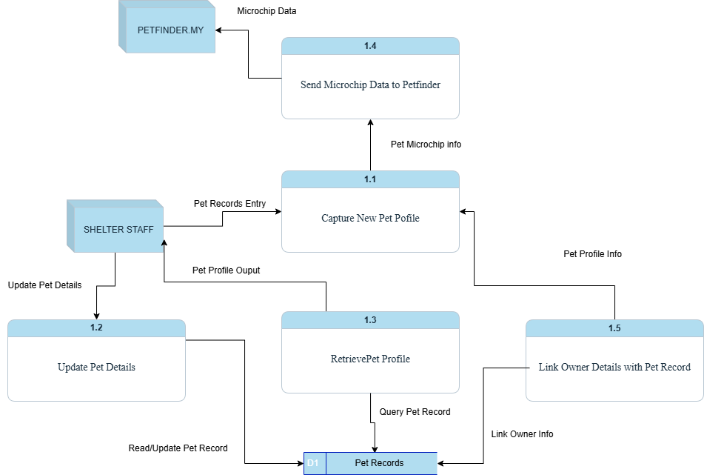

**DATA DICTIONARY**

PROCESS TABLE

|  |  |  |  |
| --- | --- | --- | --- |
| Process Name | Description | Data Flow In | Data Flow Out |
| 1.1 Capture New Pet Profile | Records a new pet’s data and links it with owner info | Pet Records Entry, Pet Profile Info | Pet Microchip Info |
| 1.2 Update Pet Details | Updates existing pet profile details | Update Pet Details | Updated Pet Record |
| 1.3 Retrieve Pet Profile | Retrieves pet profile from database | Query Pet Record | Pet Profile Output |
| 1.4 Send Microchip Data to Petfinder | Sends microchip info to PETFINDER.MY | Pet Microchip Info | Microchip Data |
| 1.5 Link Owner Details with Pet Record | Associates pet profile with owner details | Link Owner Info, Query Pet Record | Pet Profile Info |

ENTITY TABLE

|  |  |  |  |
| --- | --- | --- | --- |
| Entity Name | Description | Data Flow In | Data Flow Out |
| Shelter Staff | Shelter personnel who manage pet profiles | Pet Profile Output | Pet Records Entry, Update Pet Details |
| PETFINDER.MY | External pet listing platform | Microchip Data | N/A |
| Owner | Individual providing pet ownership information | N/A | Link Owner Info |

DATA FLOW TABLE

|  |  |  |  |  |
| --- | --- | --- | --- | --- |
| Data Flow Name | Source | Destination | Description | Data Structure |
| Pet Records Entry | Shelter Staff | 1.1 Capture New Pet Profile | New pet details entered by staff | Pet ID +  Name +  Breed +  Age+ (Microchip ID) |
| Update Pet Details | Shelter Staff | 1.2 Update Pet Details | Modified details for existing pets | Pet ID + {Updated Field} + Timestamp |
| Pet Profile Output | 1.3 Retrieve Pet Profile | Shelter Staff | Displays retrieved pet profile to staff | Pet ID +  Name +  Breed +  Status + (Owner ID) |
| Query Pet Record | 1.5 Link Owner Details | 1.3 Retrieve Pet Profile | Used to fetch pet profile for linking | Pet ID |
| Pet Microchip Info | 1.1 Capture New Pet Profile | 1.4 Send Microchip Data to Petfinder | Microchip ID extracted from pet info | Microchip ID+ Pet ID +  Breed |
| Microchip Data | 1.4 Send Microchip Data to Petfinder | PETFINDER.MY | Sent for publishing on petfinder.my | Microchip ID + Pet Name + Breed +  Age |
| Pet Profile Info | 1.5 Link Owner Details | 1.1 Capture New Pet Profile | Combined profile from owner and pet data | Pet ID +  Owner ID + Owner Name |
| Link Owner Info | Owner | 1.5 Link Owner Details with Pet Record | Owner details to associate with pet | Owner ID + Name +  Contact Number + Address |

DATA STORE TABLE

|  |  |  |  |
| --- | --- | --- | --- |
| Data Store Name | Description | Data Flow In | Data Flow Out |
| D1 Pet Records | Stores all pet profiles including microchip and owner link | Updated Pet Record, Linked Owner Info | Pet ID +  Name +  Microchip ID + Owner ID +  Status |

## **9.5** Sazid Ur Rahman Khan

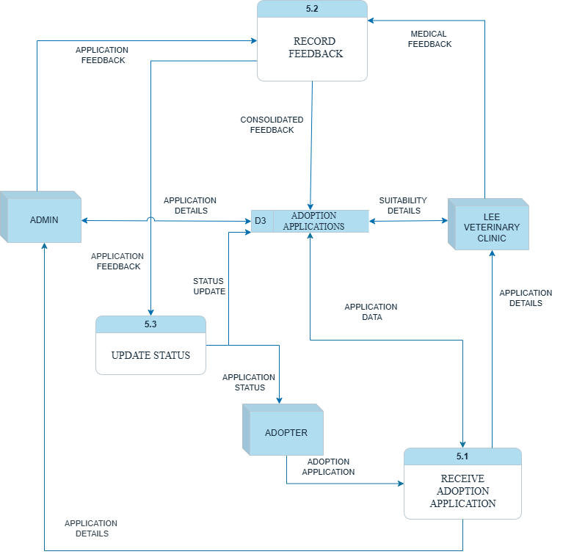

**DATA DICTIONARY**

PROCESS TABLE:

|  |  |  |  |
| --- | --- | --- | --- |
| **Name** | **Description** | **Input Data Flow** | **Output Data Flow** |
| 5.1 Receive Adoption Application | Receives the adoption application submitted by the adopter. | Adoption Application (from Adopter) | Application Details (to D3) |
| 5.2 Record Feedback | Consolidates feedback received from Admin and Lee Veterinary Clinic. | Application Feedback (from Admin), Medical Feedback (from Lee Veterinary Clinic) | Consolidated Feedback (to D3) |
| 5.3 Update Status | Updates the application status based on the recorded feedback and notifies the adopter. | Status Update (from D3) | Application Status (to Adopter), Updated Application Status (to D3) |

EXTERNAL ENTITY TABLE:

|  |  |  |  |
| --- | --- | --- | --- |
| **Name** | **Description** | **Input Data Flow** | **Output Data Flow** |
| Adopter | The individuals applying to adopt a pet and receiving application status notification. | Application Status (from 5.3 Update Status) | Adoption Application (to 5.1 Receive Adoption Application) |
| Admin | Internal entity responsible for reviewing adoption applications and giving feedback. | Application Details (from D3 Adoption Applications) | Application Feedback (to 5.2 Record Feedback) |
| Lee Veterinary Clinic | External entity responsible for reviewing medical suitability of the application. | Suitability Details (from D3 Adoption Applications) | Medical Feedback (to 5.2 Record Feedback) |

DATA FLOW TABLE:

|  |  |  |  |  |
| --- | --- | --- | --- | --- |
| **Name** | **Description** | **Origin / Source** | **Destination** | **Data Structure** |
| Adoption Application | The initial application submitted by the adopter. | Adopter | 5.1 Receive Adoption Application | ApplicationID +  ApplicantName +  ContactInfo +  PetPreference + (SubmissionDate) |
| Application Details | Details extracted from the adoption application for review. | D3 Adoption Applications | Admin, Lee Veterinary Clinic | ApplicationID +  ApplicantName +  ContactInfo +  PetPreference +  (SubmissionDate) |
| Application Feedback | Feedback provided by the Admin after reviewing the application. | Admin | 5.2 Record Feedback | ApplicationID +  AdminComments +  (AdminFlags) +  ReviewDate |
| Medical Feedback | Assessment and recommendations from the Lee Veterinary Clinic. | Lee Veterinary Clinic | 5.2 Record Feedback | ApplicationID +  VetComments +  SuitabilityRating +  {MedicalRecommendations} |
| Consolidated Feedback | Combined and finalized feedback from both Admin and Vet Clinic. | 5.2 Record Feedback | D3 Adoption Applications | ApplicationID +  AdminComments +  VetComments +  FinalRecommendation + ApprovalStatus |
| Application Status | The final status of the adoption application (e.g., approved, rejected, pending). | 5.3 Update Status | Adopter | ApplicationID +  Status +  MessageToAdopter |
| Status Update | Internal update of the application's status in the data store. | 5.3 Update Status | D3 Adoption Applications | ApplicationID +  NewStatus +  StatusChangeDate |
| Suitability Details | Specific pet and adopter details sent to the vet clinic for medical review. | D3 Adoption Applications | Lee Veterinary Clinic | ApplicationID +  PetID +  AdopterID +  PetMedicalHistory +  AdopterLivingSituation |

DATA STORE TABLE:

|  |  |  |  |  |
| --- | --- | --- | --- | --- |
| **Name** | **Description** | **Input Data Flows** | **Output Data Flows** | **Data Structure** |
| D3 Adoption Applications | Stores all that data that are related to the adoption applications, including raw data, reviewed details, feedback, and final status. | Application Details (from 5.1 Receive Adoption Application), Consolidated Feedback (from 5.2 Record Feedback), Status Update (from 5.3 Update Status) | Application Details (to Admin), Suitability Details (to Lee Veterinary Clinic), Status Update (to 5.3 Update Status) | ApplicationID +  ApplicantName +  ContactInfo +  PetPreference +  (SubmissionDate) +  (AdminComments) +  (AdminFlags) +  (VetComments) +  (SuitabilityRating) +  {MedicalRecommendations} +  FinalRecommendation +  CurrentStatus +  LastUpdateDate |

## **9.6** Mahrus Shamsul Ahsan

Figure 43 shows DFD Level 1 Overview for Process 3: Schedule Volunteer Task

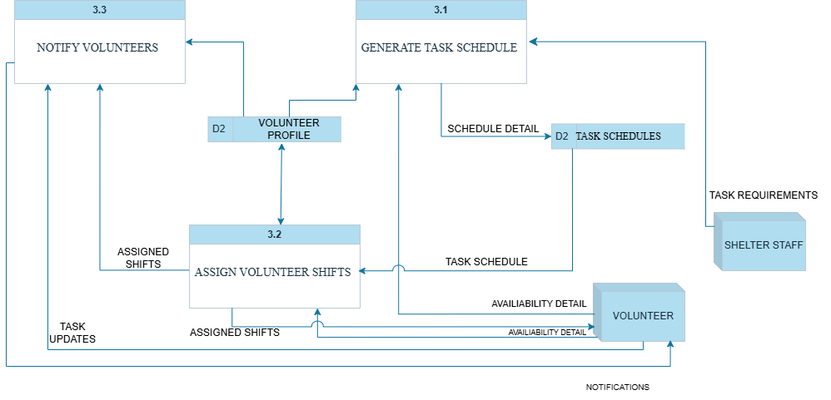

**DATA DICTIONARY**

PROCESS TABLE:

|  |  |  |  |
| --- | --- | --- | --- |
| **Name** | **Description** | **Input Data Flow** | **Output Data Flow** |
| 3.1 Generate Task Schedule | Creates shift schedules based on volunteer availability and shelter task requirements. | Volunteer availability, volunteer details, task requirements | Schedule details |
| 3.2 Assign Volunteer Shifts | Assigns volunteers to scheduled tasks based on availability and profiles. | Task schedule, volunteer details | Assigned tasks |
| 3.3 Notify Volunteers | Sends task notifications to volunteers for assigned shifts. | Assigned task and shifts details | Notifies volunteer |

ENTITY TABLE:

|  |  |  |  |
| --- | --- | --- | --- |
| **Name** | **Description** | **Input Data Flow** | **Output Data Flow** |
| Shelter Staff | Enters task requirements and reviews schedules. |  | Task requirements |
| Volunteer | Provides availability and receives task assignments. | Availability, Task update | Notifications |

DATA STORE TABLE:

|  |  |  |  |  |
| --- | --- | --- | --- | --- |
| **Name** | **Description** | **Input Data Flows** | **Output Data Flows** | **Data Structure** |
| Task Schedules | Stores all scheduled shifts and task allocations. | Schedule details | Task schedule and details | TaskID +  task +  Due Date + volunteerID + staffID |
| Volunteer Profile | Holds data about volunteer and their availability | Volunteer details | Volunteer availability | Volunteer name+ volunteerID + volunteer number + volunteer email + availability |

DATA FLOW:

|  |  |  |  |  |
| --- | --- | --- | --- | --- |
| **Name** | **Description** | **Source** | **Destination** | **Data Structure** |
| Task Requirements | Details of tasks needing volunteer assignment. | Shelter Staff | Generate Task Schedule | taskID +  task +  staffID |
| Availability Detail | Volunteer availability and preference details. | Volunteer | Generate task schedule | volunteerID + [availability] |
| Schedule Detail | Shift allocation output from scheduling engine. | Generate task schedule | Task schedules | Schedule date + staffID |
| Task Schedule | Retrieved shift schedule for assigning volunteers. | Task schedules | Assign volunteer shifts | TaskID +  task +  Due Date + volunteerID + staffID |
| Assigned Shifts | Final task assignments per volunteer. | Assign volunteer shifts | Notify volunteer | taskID +  task + volunteerID |
| Notifications | Shift assignment reminders or updates. | Notify volunteers | Volunteer | Notification + timestamp |
| Task Update | Task completion or volunteer feedback. | Volunteer | Notify volunteers | taskID + volunteerID + staffID +  update + timestamp |

# REFERENCES

Barney, N. (2024, November). *What is a software requirements specification (SRS)?* Retrieved from TechTarget: https://www.techtarget.com/searchsoftwarequality/definition/software-requirements-specification

Copeland, B. (2025, May 13). *artificial intelligence*. Retrieved from Britannica: https://www.britannica.com/technology/artificial-intelligence

Cote, C. (2021, October 26). *What Is Predictive Analytics? 5 Examples*. Retrieved from Harvad Business School Online: https://online.hbs.edu/blog/post/predictive-analytics

Coursera Staff. (2024, November 22). *What Is UI Design? Definition, Tips, Best Practices*. Retrieved from Coursera: https://www.coursera.org/articles/ui-design

Coursera Staff. (2025, May 8). *What Is a Management Information System (MIS)? Careers and Degrees*. Retrieved from Coursera: https://www.coursera.org/articles/management-information-system

Design Gurus Team. (2024, April 25). *What is system design specification?* Retrieved from Design Gurus: https://www.designgurus.io/answers/detail/what-is-system-design-specification

Fredricks, A. (2024, March 5). *How AI Staff Scheduling Is Putting People First*. Retrieved from MakeShift: https://blog.makeshift.ca/ai-staff-scheduling#:~:text=Using%20AI%20for%20staff%20scheduling%20saves%20you%20significant%20time%20and,helps%20ensure%20accurate%20staff%20schedules.

GeeksforGeeks. (2024, January 2025). *Agile Software Development Methodology | Framework, Principles, and Benefits*. Retrieved from GeeksforGeeks: https://www.geeksforgeeks.org/agile-software-development-methodology-framework/

GeeksforGeeks. (2025, April 9). *Project Planning: How to Make a Project Plan*. Retrieved from GeeksforGeeks: https://www.geeksforgeeks.org/project-planning/

GeeksforGeeks. (2025, March 25). *Software Development Life Cycle (SDLC)*. Retrieved from GeeksforGeeks: https://www.geeksforgeeks.org/software-development-life-cycle-sdlc/

Grant, M. (2024, August 14). *Gantt Chart: Definition, Benefits, and How It’s Used*. Retrieved from Investopedia: https://www.investopedia.com/terms/g/gantt-chart.asp

Gregg Lindemulder, M. K. (2024, November 22). *What is a data flow diagram (DFD)?* Retrieved from IBM: https://www.ibm.com/think/topics/data-flow-diagram#:~:text=A%20data%20flow%20diagram%20(DFD)%20is%20a%20visual%20representation%20of,management%20and%20agile%20software%20development.

Hayward, E. (2024, October 14). *What is a data dashboard?* Retrieved from Klipfolio: https://www.klipfolio.com/blog/what-is-a-data-dashboard

Jim Holdsworth, C. S. (2024, August 11). *What is NLP (natural language processing)?* Retrieved from IBM: https://www.ibm.com/think/topics/natural-language-processing

Jim Holdsworth, M. S. (2024, June 17). *What is deep learning?* Retrieved from IBM: https://www.ibm.com/think/topics/deep-learning

Kanade, V. (2022, April 4). *What Is Machine Learning? Definition, Types, Applications, and Trends*. Retrieved from spiceworks: https://www.spiceworks.com/tech/artificial-intelligence/articles/what-is-ml/

Motion Blog. (2023, November 27). *Smart Scheduling: How AI Is Reshaping Time Management*. Retrieved from UseMotion: https://www.usemotion.com/blog/smart-scheduling

Team Asana. (2025, January 14). *How to write a software requirement document (with template)*. Retrieved from Asana: https://asana.com/resources/software-requirement-document-template

Woods, M. (2025, April 20). *What is Asset Tracking? Learn How It Works, Why Its Important, Its Purpose, Benefits and How to Track Assets*. Retrieved from Camcode: https://www.camcode.com/blog/what-is-asset-tracking/?srsltid=AfmBOooXNHwgqBECaM03Jc3UWIyUEvCk5lTt7OFEzdq1O0vQzV3eoBD1

Zhang, E. (2018, August 20). *What is Role-Based Access Control (RBAC)? Examples, Benefits, and More*. Retrieved from digitalguardian: https://www.digitalguardian.com/blog/what-role-based-access-control-rbac-examples-benefits-and-more